**ICS** 23.020.30

**J** 74

GB

National standard of the people's Republic of China

**GB/T**5099.3—2017

Partly replace GB/T5099—1994

**Seamless steel gas cylinders—**

**Part 1: Normalized cylinders**

(ISO9809-3:2010, Gas cylinders—Refillable seamless steel gas cylinders—

Design, construction and testing—Part3: Normalized cylinders, NEQ)

（2020.5.28征求意见稿）

Issued on December 29, 2017 Implemented on January 1, 2019

Issued by: General Administration of Quality Supervision, Inspection and Quarantine of the People's Republic of China and Standardization Administration of the People's Republic of China

**Contents**

**Foreword**

**1 Scope**

**2 Normative references**

**3 Terms, definitions and symbols**

**4 Structure and parameter**

**5 Technical requirements**

**6 Test method**

**7 Test and inspection**

**8 Marking, coating, package, transportation and storage**

**9 Product certificate and batch inspection quality certificate**

**Annex A** (informative) **Torque of cylinder valve installation**

**Annex B** (normative) **Ultrasonic examination**

**Annex C** (normative) **Magnetic particle test**

**Annex D** (normative) **Flattening test**

**Annex E** (informative) **Description and evaluation of manufacturing imperfections and conditions for rejection of seamless steel gas cylinders at time of final inspection by the manufacturer**

**Annex F** (informative)**Quality certificate for batch inspection of seamless steel gas cylinder**

**Foreword**

GB/T 5099 consists of the following parts, under the general title of Seamless steel gas cylinders:

Part 1: Quenched and tempered steel cylinders with tensile strength less than 1 100 MPa

Part 2: Quenched and tempered steel cylinders with tensile strength greater than or equal to 1 100 MPa

Part 3: Normalized steel cylinders

Part 4: Seamless stainless steel gas cylinders

This part is Part 3 of GB/T 5099.

This part is prepared in accordance with the rules given in GB/T 1.1-2009.

This part replaces part of GB /T 5099-1994, which has been technically revised by the following:

* Adjusted the scope as below:

1. The nominal working pressure is changed from 8 MPa ~ 30 MPa to not greater than 15 MPa;
2. The nominal water capacity is changed from 0.4 l ~ 80 l to 0.5 l ~ 150 l;
3. The service temperature is - 20 ℃ ~ 60 ℃;
4. The provision of " It is not applicable to fire-fighting steel cylinder" is deleted.

* Expanded cylinder specifications

1. Requirements on size of diameter are deleted;
2. The list of filling media and the requirements for pressure grading are deleted;

* The calculation formula of wall thickness is changed;
* The requirement of finite element analysis for the base of cylinder is deleted;
* The quantity of each batch is specified as “quantity of up to 500 cylinders plus cylinders for destructive testing”;
* The requirement of batch inspection of metallographic structure after heat treatment of the cylinder is changed to that of proto-type test;
* The requirement of leak test on bottom for cylinder produced by seamless steel tube is added;
* The permanent volumetric expansion of cylinder shall be hydraulic tested by water jacket method;
* The requirement of hardness test after heat treatment is deleted;
* The measured water volume stamped in the cylinder is changed to the nominal water volume
* Annex of *Torque of cylinder valve installation* is added;
* Annex of *Ultrasonic examination* is added;
* Annex of *Magnetic particle test* is added;
* Annex of *Flattening test* is added;
* Annex of *Description and evaluation of manufacturing imperfections and conditions for rejection of seamless steel gas cylinders at time of final inspection by the manufacturer* is added.

This part is prepared with reference to ISO9809-3:2010 *Gas cylinders—Refillable seamless steel gas cylinders— Design, construction and testing—Part3:Normalized cylinders.*

The consistency between this part and ISO 9809-3:2010 *Gas cylinders—Refillable seamless steel gas cylinders— Design, construction and testing—Part3:Normalized cylinders* is not equivalent.

Attention is drawn to the possibility that some of the elements of this document may be the subject of patent rights. The issuing authority of this document shall not be held responsible for identifying any or all such patent rights.

This part is prepared and directed by National technical committee of standardization for cylinders (SAC/TC31)

This part is prepared by: Zhang Zengying, Shi Fengwen, Xie Yuemei, Chen Weiming, Wu Yan and Zhang Baoguo, who are from Beijing Tianhai Industry Co., Ltd., Shanghai High Pressure Vessel Co., Ltd., and Jingsu Tianhai Special Equipment Co.,Ltd. respectively.

This part cancels and replaces the following past edition:

GB5099—1985 and GB/T5099—1999

**Seamless steel gas cylinders**

**Part 3:Normalized cylinders**

**1 Scope**

This part of GB/T 5099 specifies minimum requirements for structure and parameter, technical requirements, test method, test and inspection rule, marking, coating, package, transportation and storage, product certificate and batch inspection quality certificate of normalized cylinders (hereinafter referred to as steel cylinders)

This part of GB/T 5099 is applicable to refillable steel cylinder of design and construction with nominal working pressure not greater than 15 MPa, nominal water capacities of 0,5 l ~ 150 l and service temperature with range of ˗40 ℃ ~ 60 ℃, which is used for filling compressed gas or high-pressure liquefied gas.

This part of GB/T 5099 does not apply to the gas cylinder for vehicle and cylinder-type pressure vessel attached to machines and equipment.

Note: If desired, cylinders of water capacity less than 0,5 l can be manufactured and certified to be in compliance with this part of GB/T 5099.

**2 Normative references**

The following referenced documents are indispensable for the application of this document. For dated references, only the edition cited applies. For undated references, the latest edition of the referenced document (including any amendments) applies.

GB/T 196 General purpose metric screw threads--Basic dimensions(ISO 724)

GB/T 197 General purpose metric screw threads—Tolerances(ISO 965-1)

GB/T 222 Permissible tolerances for chemical composition of steel products

GB/T 223 Methods for chemical analysis of iron，steel and alloy

GB/T 224 Determination of depth of decarburization of steels(ISO 3887)

GB/T 228.1 Metallic materials - Tensile testing - Part 1 : Method of test at room

temperature(ISO 6892)

GB/T 229 Metallic materials - Charpy pendulum impact test method(ISO 148-1)

GB/T 232 Metallic materials - Bend test(ISO 7438)

GB/T 4336 Carbon and low-alloy steel—Determination of multi-element contents—Spark discharge atomic emission spectrometric method (routine method)

GB/T 5777-2008 Seamless steel pipe and tubing methods for ultrasonic testing

(ISO 9303:1989,MOD)

GB/T 6394 Determination of estimating the average grain size of metal

GB/T 7144 Colored cylinder mark for gases

GB/T 8335 Special threads for gas cylinders

GB/T 8336 Special thread gauges for gas cylinders

GB/T 9251 Methods for hydrostatic test of gas cylinders

GB/T 9252 Method for pressure cycling test of gas cylinders

GB/T12137 Methods for leakage test of gas cylinders

GB/T 13005 Terminology of gas cylinders

GB/T 13298 Inspection methods of microstructure for metals

GB/T 13299 Steel--Determination of microstructure

GB/T 13447 Steel blank for seamless gas cylinder

GB/T 15384 Designation for gas cylinders

GB/T 15385 Method for hydraulic burst test of gas cylinder

GB/T 18248 Seamless steel tubes for gas cylinder

JB/T 6065 Non-destructive testing—Shims for magnetic particle testing

**3 Terms, definitions and symbols**

**3.1 Terms and definitions**

For the purposes of this document, the terms and definitions given in GB / T13005 and the following terms and definitions apply.

**3.1.1**

**yield stress**

In tensile test, if it exhibits a defined yield, stress value corresponding to the upper yield strength; or for steels which do not exhibit a defined yield, the 0,2% proof strength (non-proportional extension).

**3.1.2**

**normalizing**

heat treatment in which a cylinder is heated to a uniform temperature above the upper critical point, Ac3, of the steel and then cooled in still air

**3.1.3**

**tempering**

toughening heat treatment which follows quenching, in which the cylinder is heated to a uniform temperature below the lower critical point, Ac1, of the steel, keep it for a certain time, and then cool to room temperature.

**3.1.4**

**batch**

Quantity of cylinders of the same design made successively on the same equipment, from the same cast of steel and subjected to the same heat treatment for the same duration of time

**3.2 Symbols**

For the purposes of this document, the following symbols apply.

*A* Percentage elongation after fracture, in %

*C* Circumferential length of branch of bursting profile, in mm

*D* Nominal outside diameter of the cylinder, in mm

*D*fDiameter of former in bend test, in mm

*F* Design stress factor (see 5.2.5.)

*H* Outside height of convex base end, in mm

*L*0 Original gauge length of flat test piece, in mm

*P*b Measured burst pressure, in MPa

*P*h Hydraulic test pressure, in MPa

*P*w Nominal working pressure, in MPa

*P*y Observed pressure when cylinder starts yielding during hydraulic burst test, in MPa

*R*e Minimum guaranteed value of the yield strength after heat treatment, in MPa

*R*ea Actual value of the yield strength, in MPa

*R*g Minimum guaranteed value of the tensile strength after heat treatment, in MPa

*R*m Actual value of tensile strength, in MPa

*S* Guaranteed minimum thickness of the cylindrical shell, in mm

*S*a Average value of measured cylindrical shell thickness, in mm

*S*0 Original cross-sectional area of flat test piece, in square mm

*S*1 Guaranteed minimum thickness at the center of a concave base, in mm

*S*2 Guaranteed minimum thickness of a concave base at the knuckle, in mm

*T* Depth of reference standard, in mm

*V* Nominal water volume, in litres

*W* Width of reference standard, in mm

*a*kV Impact value, in J/cm2

*a* Original thickness of arc flat test piece, in mm

*b* Original width of flat test piece, in mm

*h* Outside depth(concave base end), in mm

*l* Length of cylindrical shell, in mm

*r*  Inside knuckle radius, in mm

**4 Structure and parameter**

**4.1 Structure**

The cylinder shall conform to the structure shown in Figure 1 generally.

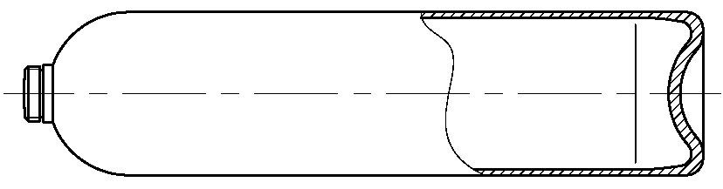

1. Concave end

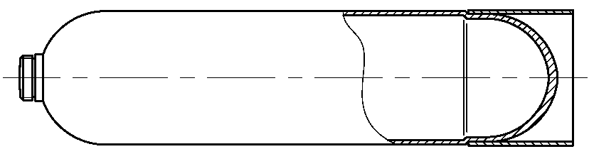

1. Hot forming end

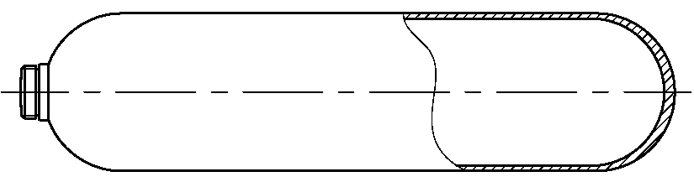

1. Convex end

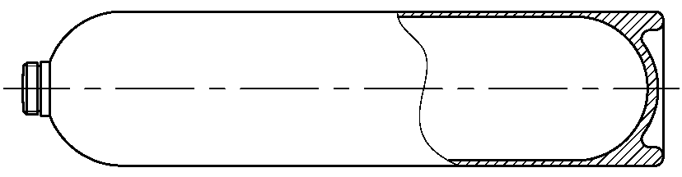

1. H – shape end

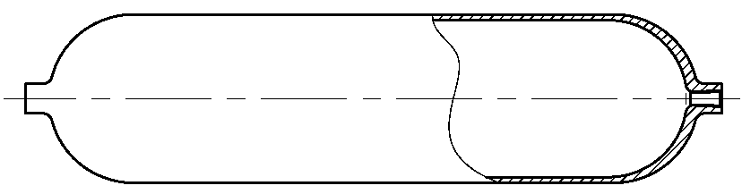

1. Double opening end

**Figure 1 ~~-~~ Cylinder structure type**

**4.2 Parameter**

The nominal water capacity and allowable tolerance of steel cylinder shall meet the requirements in Table 1.

**Table 1 - Nominal water capacity and its allowable tolerance/ of steel cylinder**

|  |  |
| --- | --- |
| Nominal water capacity /l | Allowable tolerance/% |
| 0,5 ～ 2 | + 20  0 |
| >2 ～ 12 | + 10  0 |
| >12 ～ 150 | + 5  0 |

**4.3 Designation**

The designation method of steel cylinder shall comply with GB / T 15384.

**5 Technical requirements**

**5.1 Materials**

**5.1.1 General requirements**

**5.1.1.1** The material used for the manufacture of gas cylinders shall be the fully killed steel with non-ageing properties, made by electric furnace or oxygen blowing converter.

**5.1.1.2** The material shall be high-quality carbon manganese steel.

**5.1.1.3** The material of the steel cylinder shall meet the requirements of relevant standards, with the original quality certificate or the copy stamped with the official seal of the material supplier and the seal of the person in charge. The cylinder manufacturer shall verify and analyze the chemical composition of the material through the cast number.

**5.1.1.4** Chemical composition limits of material of steel cylinder, see Table 2, the permissible tolerance shall be in accordance with GB/T 222.

**Table 2 - Chemical composition limits of material of steel gas cylinder** (mass fraction)

|  |  |
| --- | --- |
| Element | Steel |
| Carbon manganese |
| Carbon | ≤0,38% |
| Silicon | 0,10%~0.35% |
| Manganese | 1,35%~1.75% |
| Sulfur | ≤0,020 |
| Phosphorus | ≤0,020 |
| Sulfur + phosphorus | ≤0,030 |

**5.1.2 Billet**

**5.1.2.1** The shape, dimension and allowable tolerance of billet shall comply with GB/T 13447.

**5.1.2.2** The macrostructure of steel shall be free of white spots, residual shrinkage cavities, delamination, bubbles, foreign matters and inclusions; the center porosity shall not be greater than grade 1,5 , and the segregation shall not be greater than grade 2,5.

**5.1.3 Seamless steel tube**

**5.1.3.1** The dimension, shape, internal and external surface quality and allowable tolerance of seamless steel tube shall comply with GB/T 18248.

**5.1.3.2** Seamless steel tube shall be examined for longitudinal and transverse imperfections by ultrasonic detection one by one in accordance with GB/T 5777-2008, and the detection result shall comply with level L2 of GB/T 5777-2008.

**5.2 Design**

**5.2.1 General**

**5.2.1.1** The calculation of the wall thickness shall be related to the minimum guaranteed yield strength, *R*e, of the material in the finished cylinder.

**5.2.1.2** Minimum guaranteed value, *R*e, of the yield strength after heat treatment used in design calculation, shall not exceed 75% of minimum guaranteed value, *R*g, of the tensile strength, after heat treatment.

**5.2.1.3**The hydraulic test pressure, *P*h, of the cylinder shall be at least 1,5 times of the nominal working pressure. The allowable service pressure of the cylinder shall not exceed 0,8 times of the hydraulic test pressure, *P*h.

**5.2.1.4** The maximum value of the tensile strength, after normalizing or normalizing and tempering, shall be less than 800 MPa.

**5.2.2 Calculation of cylindrical shell thickness**

The guaranteed minimum thickness of the cylindrical shell, S, shall be the thickness calculated using Equations (1), and rounded up to one decimal point. The wall thickness shall also satisfy Equation (2) with an absolute minimum of *S* = 1,5 mm.

|  |  |
| --- | --- |
|  | ………………(1) |

where the value of *F*≤0,85

|  |  |
| --- | --- |
|  | ………………(2) |

**5.2.3 Calculation of end thickness**

**5.2.3.1** The convex end structure of the cylinder is generally shown in Figure 2, where a), b), d), e) is the base shape, c) and f) is the head shape.

**5.2.3.2** The region where the convex end joins the shell shall be transited smoothly from the point of juncture, with thickness not less than the guaranteed minimum thickness of the cylindrical shell, *S*. Where the inside knuckle radius, r, is not less than 0,075*D*, then the thickness at the center of a convex end, *S*1, is required by the following criteria:

a) *S*1≥1,5S for 0,2≤*H*/*D* <0,4 and

b) *S*1≥S for *H*/*D*≥0,4

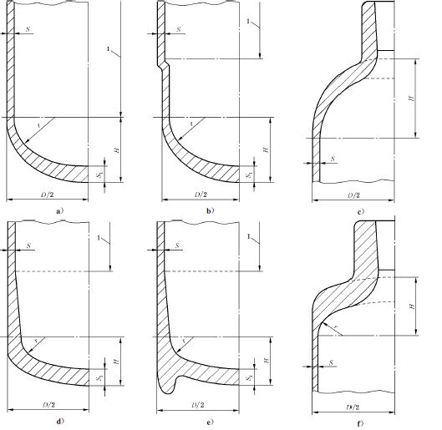

**Key**

1 cylindrical part

**Figure 2 ~~-~~ Typical convex ends**

**5.2.3.3** When concave base ends (see Figure 3) are used, the design values shall satisfy the following requirements:

a) *S*1≥2*S*

b) *S*2≥2*S*

c) *r*≥0,075*D*

d) *h*≥0,12*D*.

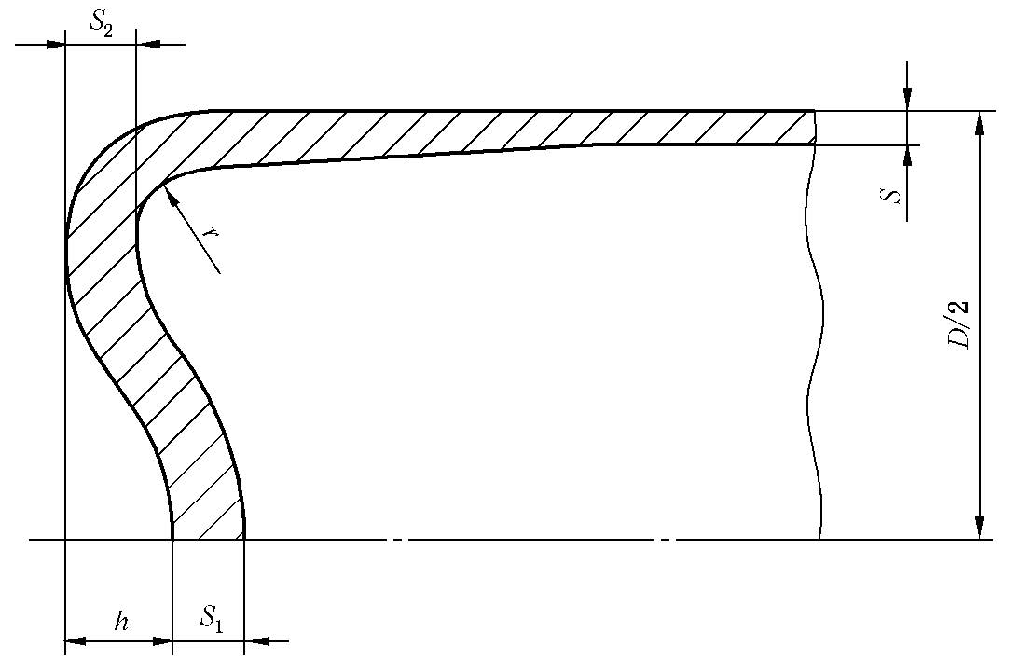

**Figure 3 ~~-~~ Concave base end**

**5.2.3.4** The region where the concave end joins the shell shall be transited smoothly from the point of juncture, the thickness at the center of a concave end shall not be less than guaranteed minimum thickness of the cylindrical shell, *S*.

**5.2.3.5** When the cylinder with concave base end stands vertically, outside knuckle diameter shall not be less than 0,75*D* to give the cylinder sufficient stability.

**5.2.3.6** The cylinder manufacturer shall prove by the hydraulic burst test and the pressure cycling test that the design is satisfactory.

**5.2.4 Neck design**

**5.2.4.1** Generally, cylinder neck thread shall be tapered thread, which shall comply with GB/T8335 or relevant standards, with the appropriate number of effective thread not less than 8; the appropriate number of effective thread of cylinder with water capacity up to 12 l shall not be less than 7. If common thread is used, the size and tolerance shall comply with GB/T196 and GB/T197 or relevant standards. The shear factor of safety calculated by the appropriate number of effective thread under the hydraulic test pressure, *p*h, shall be at least 10 and the appropriate number of effective thread shall not be less than 6.

**5.2.4.2** To prevent permanent expansion of the neck, wall thickness of the formed neck end of the cylinder shall be adequate for the torque applied in fitting the valve to the cylinder and the force applied in fitting the neck ring to the cylinder.

**5.2.5 Foot rings**

When a foot ring is provided, it shall have sufficient strength and shall be made of material compatible with that of the cylinder. The shape should preferably be cylindrical and shall give the cylinder stability. The foot ring shall be secured to the cylinder by a method other than welding, brazing or soldering. Any gaps which may form water traps shall be sealed by a method other than welding, brazing or soldering.

**5.2.6 Nick rings**

When a neck ring is provided, it shall have sufficient strength and shall be made of material compatible with that of the cylinder and shall be securely attached by a method other than welding, brazing or soldering. The manufacturer shall ensure that the axial load to remove the neck ring is greater than 10 times the weight of the empty cylinder, but not less than 1 000 N and that the torque to turn the neck ring is not less than 100 N·m.

**5.3 Construction and workmanship**

**5.3.1 General**

**5.3.1.1** Cylinder manufacturing shall be in accordance with the requirements of this part of GB/T5099, product drawings and relevant technical documents.

**5.3.1.2** The cylinder shall be produced by:

a) forging or drop forging from a solid ingot or billet with process of forming the neck, named as forged cylinder;

1. manufacturing from seamless steel tube with process of closuring the ends and forming the neck , named as spun cylinder.

**5.3.1.3** Before manufacture, the cylinder manufacturer shall make analysis of chemical composition on the cast of steel from which the cylinder are made. The analysis method shall be in accordance with GB/T223 or GB/T4336, and the results shall satisfy 5.1.

**5.3.1.4** It is not allowed for steel cylinder to be treated by welding, brazing or soldering. Imperfections in the inner surface of base of spun cylinder, such as cracks, inclusions and lack of fusion shall be removed by mechanical milling.

**5.3.1.5** Special tools are allowed to be used for grinding the surface defects of the cylinder, and the grinding inclination is not greater than 1:3.

**5.3.2 Batch**

Quantity of up to 500 for cylinders, plus cylinders for destructive testing

**5.3.3 Heat treatment**

The heat treatment process shall be applied to the finished cylinders in accordance with qualified specification of normalizing or normalizing and tempering.

**5.3.4 Ultrasonic examination**

After completion of the final heat treatment, each cylinder shall be ultrasonically examined for internal, external and sub-surface imperfections.

**5.3.5 Hydraulic test**

Hydraulic test shall be performed on each cylinder. The inner surface shall be dried without any residual water stains after the hydraulic test.

**5.3.6 Neck thread**

The profile, dimension and tolerance of the thread shall comply with GB/T8335 or relevant standards.

**5.3.7 Accessories**

**5.3.7.1** Based on the nature of gas filled, chose and install the corresponding cylinder valve. For the installation torque of taper thread valve and common thread valve, refer to the requirements of Table A.1 and Table A.2 in Appendix A for control.

**5.3.7.2** Generally, the cylinder shall be equipped with a cap or shield, which can be fixed or detachable, made of metal or resin materials, and can resist the impact of external forces.

**5.3.7.3** For accessories with threaded connection, the profile, dimension and tolerance shall comply with GB/T 8335 or relevant standards.

**6 Test method**

**6.1 Wall thickness and manufacturing tolerance.**

**6.1.1** Wall thickness of cylindrical part of steel cylinder shall be measured by ultrasonic thickness gauge.

**6.1.2** Manufacturing tolerance

Manufacturing tolerance shall be checked with standard measuring tool or special tool and template, including mean diameter, roundness, verticality and straightness of cylindrical part of steel cylinder.

**6.2 Leak test on bottom**

Use a suitable test installation, apply pressure to the inside center area of cylinder bottom to test pressure, hold the test pressure for a minimum of 1 min., check whether there is any leakage or not during pressure holding time. The inside center area bearing pressure shall not be less than 20mm in diameter around the end and at least 1/16 of the total bottom area. The test media may be clean air or nitrogen.

**6.3 Internal and external surface**

Internal and external surface shall be visual inspected. Appropriate sources of illumination with sufficient intensity shall be used for internal surface inspection with the aid of endoscope or appropriate tools.

**6.4 Neck threads**

The internal neck threads shall be visual inspected and checked by gauges. Taper thread shall be inspected in accordance with GB/T 8335 and GB/T 8336 or relevant standards, while common thread shall be inspected in accordance with GB/T 196 and GB/T 197 or relevant standards.

**6.5 Nondestructive testing**

The on-line automatic ultrasonic testing shall be carried out for non-destructive testing, but the on-line automatic magnetic particle testing can be carried out for cylinders with cylindrical length less than 200mm. Ultrasonic testing shall be carried out in accordance with Appendix B; magnetic particle testing shall be carried out in accordance with Appendix C.

**6.6 Hydraulic test**

The permanent volumetric expansion shall be hydraulic tested by water jacket method in accordance with GB/T 9251.

**6.7 Leak test**

Leak test shall be carried out in accordance with GB/T 12137.

**6.8 Mechanical property test shall be carried out after the completion of heat treatment.**

**6.8.1 Test pieces**

**6.8.1.1** For the location of test pieces, see Figure 4. The tensile test pieces shall be sectioned symmetrically at 180°along the cylindrical part.

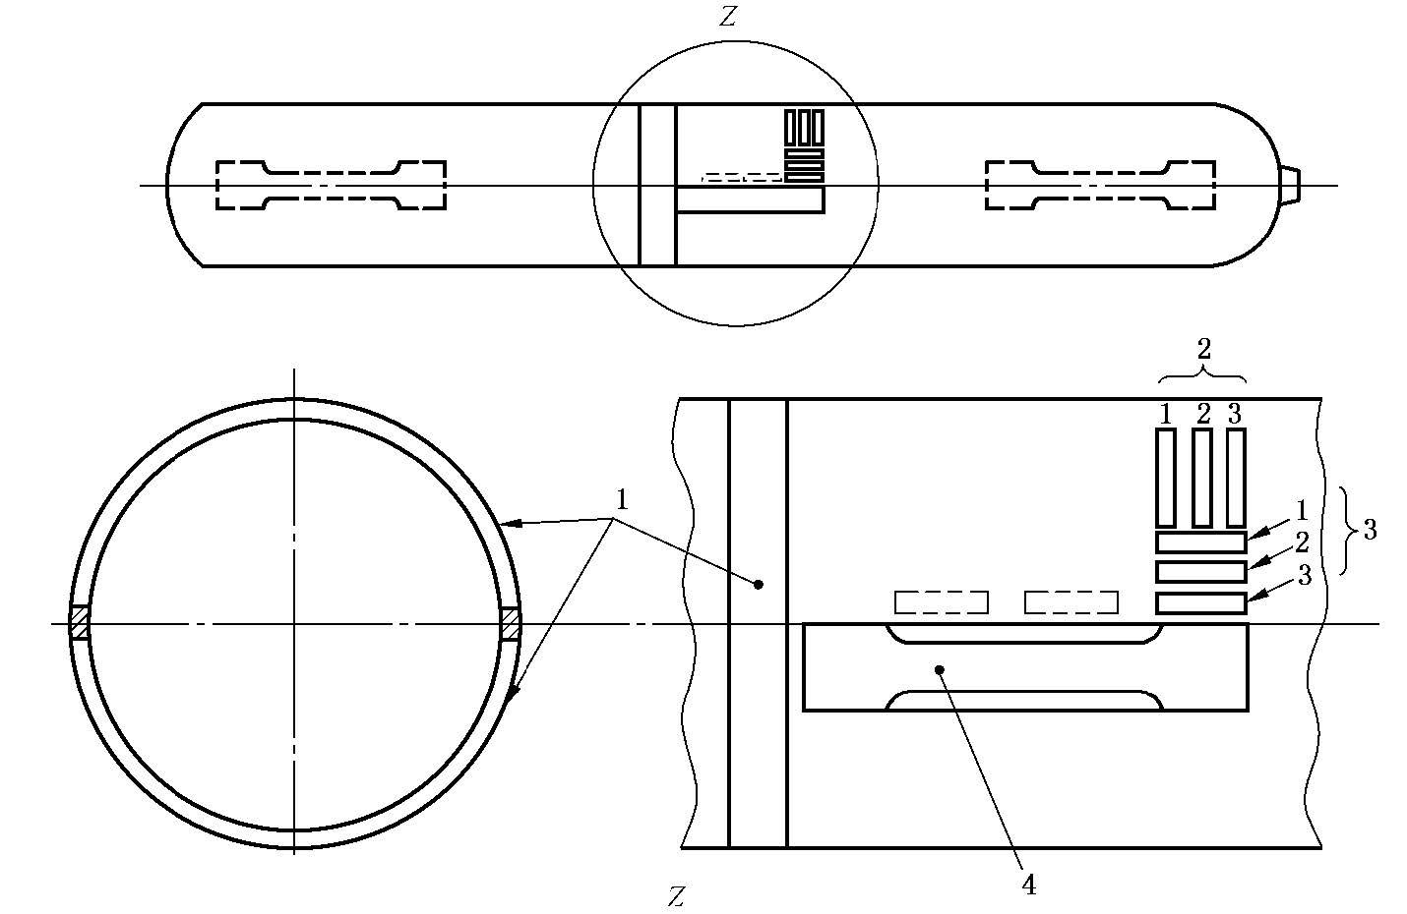

**Key**

1 - bend test pieces or flattening ring

2 - transverse impact pieces

3 - longitudinal impact test piece (alternative positions shown dashed)

4 - tensile test pieces

**Figure 4 ~~-~~ Typical location of test pieces**

**6.8.1.2** Quantity of test piece

1. Two pieces for tensile test in the longitudinal direction;
2. Three pieces for impact test in the transverse or longitudinal direction when the thickness of the cylinder permits the machining of a test piece at least 3mm thick;
3. Either two pieces for bend tests in a circumferential direction, one cylinder for flattening test or one ring for flattening test.

**6.8.2 Tensile test**

**6.8.2.1** Measurement of mechanical property of tensile strength, yield strength and percentage elongation after fracture shall be included in tensile test.

**6.8.2.2** It shall take the longitudinal arc flat test pieces with full thickness as tensile test pieces. The gripping part at both ends can be flattened. Specimens shall be prepared in accordance with Figure 5 and with a gauge length *L*0 = 5,65



**6.8.2.3** Except for the dimension of test piece set out in this part, the test shall be performed in accordance with GB/T 228.1. Before yield, grips separation rate shall be less than 3mm/min.

Unit: mm

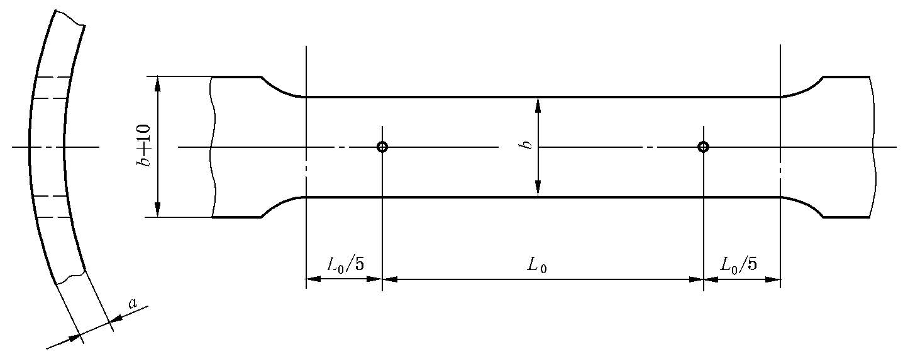

*b*≤ 4*a*, *b*˂ *D*/8

**Figure 5 ~~-~~ Tensile test piece**

**6.8.3 Impact test**

**6.8.3.1** It shall take test pieces with thickness greater than or equal to 3 mm and less than or equal to 10 mm and with a V-notch as the standard test pieces. For the outside diameter of the cylinder greater than 140mm, impact test shall be carried out laterally; for the outside diameter of the cylinder less than or equal to 140mm, impact test shall be carried out longitudinally.

**6.8.3.2** The impact test piece shall be taken from the cylinder wall. The notch shall be perpendicular to the face of the cylinder wall, see Figure 6. For longitudinal tests, the test piece shall be machined all over on six faces. If the wall thickness does not permit a final test piece

width of 10 mm, the width shall be as near as practicable to the nominal thickness of the cylinder wall. The test pieces taken in the transverse direction shall be machined on four faces only, the inside face and outside face of the cylinder wall shall not be machined and the inside face shall be machined as shown in Figure 7.

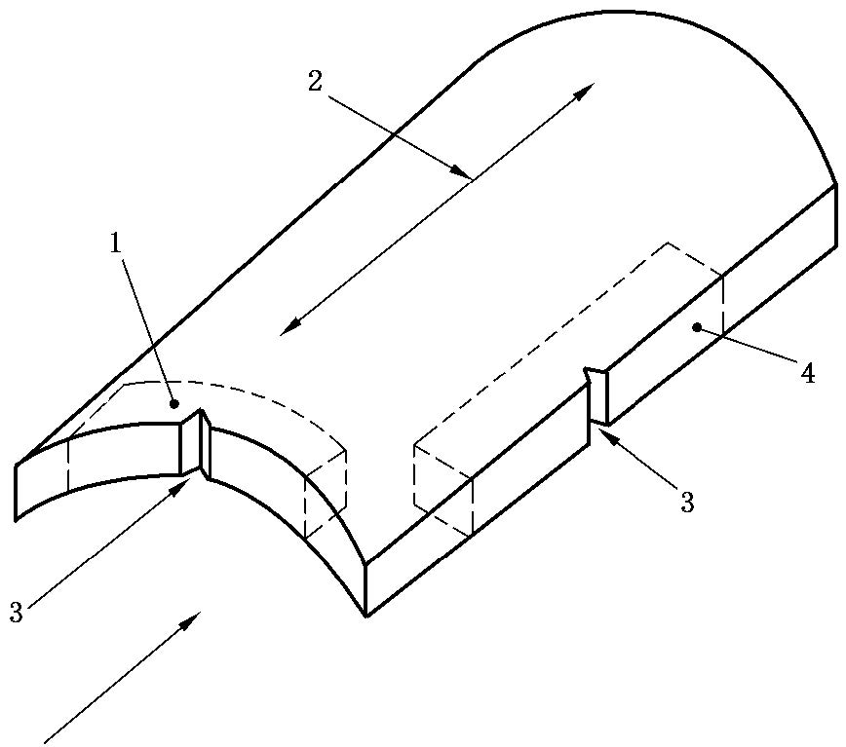

**Key**

1 transverse test piece

2 cylinder longitudinal axis

3 Charpy V-notch perpendicular to the wall

4 longitudinal test piece

**Figure 6 ~~-~~ Description of transverse and longitudinal impact test pieces**



**Key**

1 machining optional

2 striking anvil

3 test piece

4 center of strike

5 direction of strike.

**Figure 7 ~~-~~ Description of transverse impact testing**

**6.8.3.3** Excepted for the requirements set out in 6.8.3.2, test piece shape, dimension, tolerance and impact test shall be in accordance with GB/T 229.

**6.8.3.4** If the wall thickness of the cylinder is not sufficient to machine the standard test piece, the impact test can be excepted.

* + 1. **Bend test**

**6.8.4.1** The width of bend test piece shall be 4 times of the wall thickness of the cylinder, and shall not be less than 25 mm. Only 4 surfaces of the test piece may be machined, and the arc surface of the inside and outside wall of the cylinder shall not be machined.

**6.8.4.2** The test pieces shall be obtained and bend tested in accordance with GB/T 232.

See Figure 8.

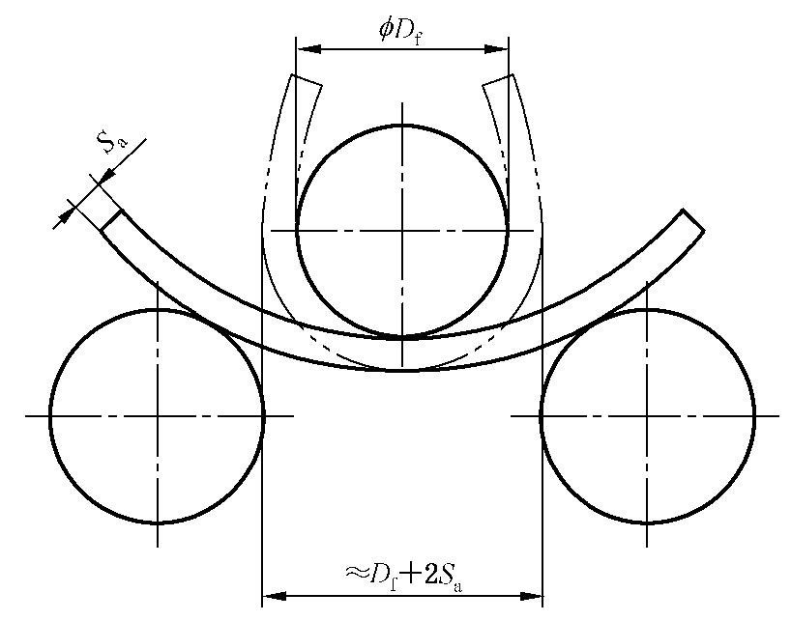

**Figure 8 ~~-~~ Illustration of bend test**

**6.8.5 Flattening test**

**6.8.5.1** Flattening test shall be carried out in accordance with Annex B.

**6.8.5.2** The ring flattening test shall be carried out on one ring of width with 4*t* and ≥25 mm , taken from the cylinder shell. Only the edges of the ring may be machined. The ring shall be flattened by two planes, parallel, rigid platens.

* 1. **Hydraulic burst test** 
     1. Hydraulic burst test shall be carried out in accordance with GB/T 15385.
     2. The pressure shall be increased at a rate of not more than 0.5 MPa/s during the test.
     3. The pressure/time curve or pressure/volume of water used curve shall be drawn

automatically to determine the yield pressure and bursting pressure.

* 1. **Base check**

A meridian section shall be made in the base center of the cylinder of tensile test and one of the surfaces thus obtained, check the dimension with standard measuring tool or special tool and template. For the spun cylinder, the section shall be etched for examination under a magnification of between × 5 and × 10.

* 1. **Metallographic test**
     1. Metallographic test piece can be taken form the cylinder of tensile test. The machining,

size and method shall comply with GB/T 13298.

* + 1. Grain size shall be determined in accordance with GB / T6394
    2. Depth of decarburization shall be determined in accordance with GB/T 224.
    3. Banded structure and Widmannstatten structure shall be determined in accordance with GB/T13299.
  1. **Pressure cycling test** 
     1. Pressure cycling test shall be carried out in accordance with GB/T 9252.
     2. The value of the upper cyclic pressure shall not be less than the hydraulic test pressure,

*P*h. The value of the lower cyclic pressure shall not exceed 2MPa.The frequency of reversals of pressure shall not exceed 10 cycles/min.

* + 1. The bases thickness of test cylinder shall be sufficiently close to the minimum thickness

prescribed in the design and shall be within the usual production tolerances. In no case shall the actual base thickness exceed the minimum value(s) specified on the drawings by more than 15 %.

* 1. **Inspection of neck ring installation**
     1. Neck removing test: fix the cylinder, apply the axial load to remove the neck ring, the

applied load shall be greater than 10 times the weight of the empty cylinder but not less than

1 000 N.

* + 1. Rotating test: apply the torque to turn the neck ring, the applied torque shall be greater

than 100 N·m.

**7. Test and inspection**

**7.1 Test and inspection criteria**

**7.1.1 Wall thickness and manufacture tolerance**

**7.1.1.1** The wall thickness at any point shall not be less than guaranteed minimum thickness specified.

**7.1.1.2** The mean external diameter of the cylindrical part outside the transition zones on a cross-section shall not deviate by more than ± 1 % from the nominal outside diameter.

**7.1.1.3** The out-of-roundness of the cylindrical shell, i.e. the difference between the maximum and minimum outside diameters at the same cross-section, shall not exceed 2 % of the mean of these diameters.

**7.1.1.4** For a cylinder designed to stand on its base, the deviation from vertical shall not exceed

10 mm/m length, *l* (see Figure 9).

**7.1.1.5** The maximum deviation of the cylindrical part of the shell from a straight line shall not exceed 3mm/m (see Figure 9).

Unit: mm

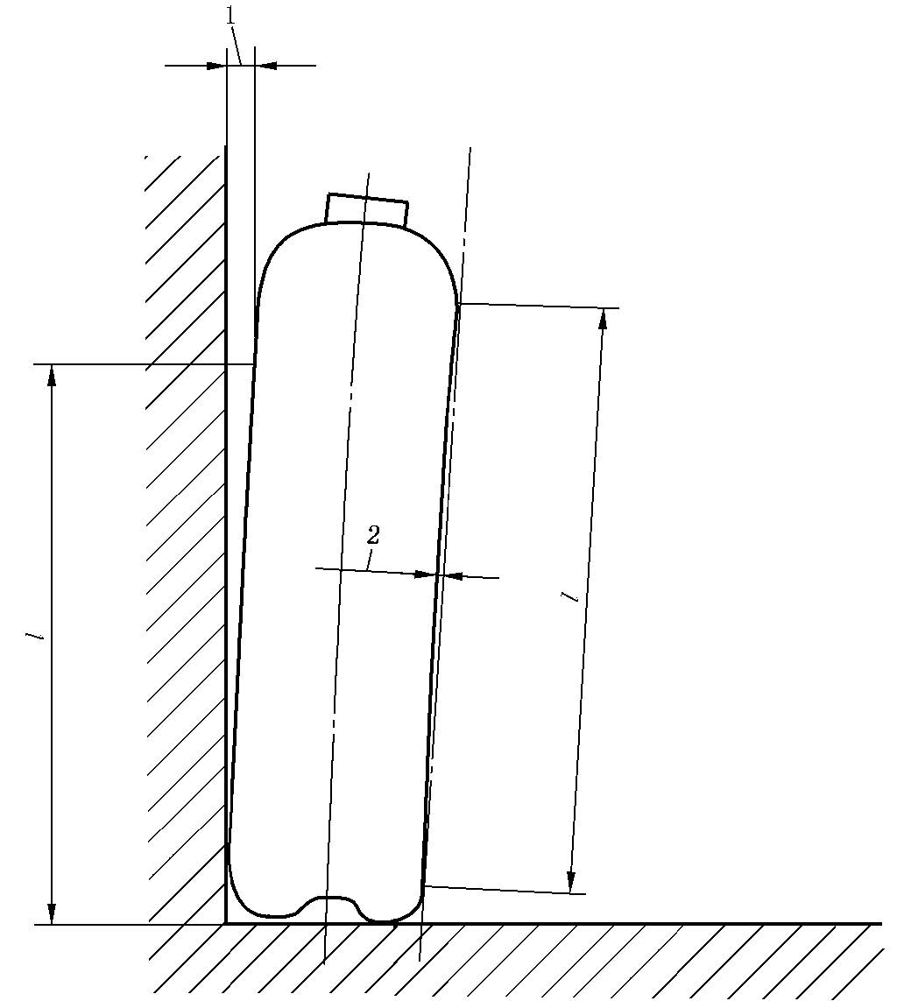

**Key**

1 — maximum 0,01 × *l* (see 7.1.1.4)

2 — maximum 0,003 × *l* (see 7.1.1.5)

**Figure 9 ~~-~~ Illustration of deviation of cylindrical part of shell**

**from a straight line and from vertical**

**7.1.2 Leak test on bottom**

The inside area of the cylinder bottom surrounding the closure shall be subjected to the cylinder nominal working pressure, *P*w , for a minimum of 1 min; the opposite side shall be covered with water without indication of leakage.

Note: For cylinders with base ends spun by seamless steel tube, this test can be replaced by a pneumatic leakage test on the whole cylinder.

**7.1.3 Internal and external surface**

**7.1.3.1** The internal and external surface shall be smooth, even and free from visible imperfections which could adversely affect the safe working of the cylinder such as dent, gouge, crack, bulge, fold and lamination. Imperfections can be removed by machining, and the minimum wall thickness specified shall be guaranteed. Examples of imperfections and assistance on evaluation, see Annex E.

**7.1.3.2** The transition area between end and cylindrical part shall be smooth, and no groove mark is allowed on the shoulder.

**7.1.4 Neck thread**

**7.1.4.1** The profile, dimension and tolerance of the taper thread shall comply with GB/T 8335 or relevant standards.

**7.1.4.2** The axial variation of taper thread base plane shall not exceed + 1.5mm.

**7.1.4.3** The common thread dimension and tolerance shall be inspected in accordance with

GB/T 196 and GB/T 197 or relevant standards, the appropriate number of effective thread shall be guaranteed for design..

**7.1.5 Nondestructive testing**

Ultrasonic testing shall be carried out in accordance with Appendix B; magnetic particle testing shall be carried out in accordance with Appendix C.

**7.1.6 Hydraulic test**

**7.1.6.1** The cylinder shall remain under pressure, *P*h, for at least 30 s to establish that the pressure does not fall and that there are no leaks or visible deformation. Volumetric permanent expansion shall not exceed 5%.

**7.1.6.2** Measured water capacity and mass shall be indicated in hydraulic test report, and shall reserve three significant digits and at least one decimal place. The rounding principle of water capacity and mass is that the water capacity is kept without rounding but the mass is rounded off.

For example, the measured value of water capacity or mass is 40,675, the water capacity is expressed as 40,6, the water mass is expressed as 40,7.

**7.1.7 Leak test**

Leak test shall be carried out on the steel cylinder with valve and filled with combustible and toxic media. The cylinder shall remain under pressure, *P*w, for at least 1 min to establish that the pressure does not fall and that there are no leaks in cylinder, valve and joint between cylinder and valve. Leakage caused by valve installation is allowed to be retested after repair.

**7.1.8 Mechanical property test shall be carried out after the completion of the heat treatment.**

**7.1.8.1** The tensile test shall be carried out in accordance with 6.8.2. The tensile strength *R*m and yield strength *R*ea shall not be less than guaranteed value after heat treatment specified by the cylinder manufacturer, and meet the requirements of 5.2.1.4 The measured ratio *R*ea/*R*m shall not exceed 0.8, and the elongation, *A*, after fracture shall be at least 20%.

**7.1.8.2** The impact test shall be carried out in accordance with 6.8.3. Minimum acceptance values shall be as given in Table 3.

**Table 3 ~~-~~ Impact test acceptance values**

|  |  |  |  |
| --- | --- | --- | --- |
| Nominal outside diameter,  *D*/mm | | >140 | ≤140 |
| Direction of testing | | transverse | longitudinal |
| Test temperature/ °C | | ˗ 20 | ˗ 20 |
| Impact value  *a*kV J/cm2 | Mean of three test pieces  Individual test piece | 20  16 | 40  32 |
| Note：The impact value is calculated by dividing the impact energy by the actual cross-sectional area below the notch of the Charpy test specimen | | | |

**7.1.8.3** Bend test and flattening test shall be carried out in accordance with 6.8.4 and 6.8.5 respectively. It is accepted without crack. The diameter of former and distance between knife edges or platens shall not exceed values specified in Table 4.

**Table 4 ~~-~~ Former diameter of bend test and distance between knife edges of flattening test**

|  |  |  |
| --- | --- | --- |
| Measured tensile strength, *R*m/MPa | Former diameter Df/mm | Distance between knife edges/mm |
| *R*m≤800 | 4*S*a | 6*S*a |

**7.1.9** Hydraulic burst test

**7.1.9.1** Examine pressure/time curve or pressure/volume of water used curve, the observed yield pressure, *P*y, and actual burst pressure, *P*b, shall be:

a) *P*y ≥ *P*h/F, and *P*y ≥ 1.18*P*h

b) *P*b ≥1.22/(*R*e/*R*g) × *P*h.

**7.1.9.2** The cylinder shall not fragment. The main fracture shall be in the cylindrical portion.

The tear in no case shall reach the neck.

**7.1.9.3** The main fracture shall not be brittle. The fracture shall be longitudinal with visible side branching. The tear shall not reveal a significant defect in the metal.

**7.1.9.4** For cylinders with a wall thickness of less than 7,5 mm, the fracture profile and dimension shall be acceptable only if it conforms to the description of Figure 10.



**Figure 10 - Acceptable burst profiles**

**7.1.10 Base check**

Check and verify that the dimensions of base conform to design according to 6.10. For the spun cylinder, there shall be no shrinkage hole, bubble, lack of fusion, crack, inclusion and other defects posing a threat to safety. In no case shall the sound thickness (i.e. the thickness with no imperfections) in the base center be less than the minimum specified thickness.

**7.1.11 Metallographic test**

**7.1.11.1** The grain size shall not be less than grade 6 (100 times), banded structure not more than grade 3 and widmanstatten structure not more than grade 2.

**7.1.11.2** Depth of decarburization on outside wall shall not exceed 0.3 mm, depth of decarburization on inside wall shall not exceed 0.25mm.

**7.1.12 Pressure cycling test**

Pressure cycling test shall be carried out on cylinders under the pressure specified in 6. 12 .The cylinders shall withstand 12 000 cycles without leak or fracture. After test, the cylinder bases shall be sectioned to measure the thickness and to ensure that the measured thickness complies with the requirements of 6.12.3.

**7.1.13 Inspection of neck ring installation**

The neck ring shall not fall off during the axial pull off test and not loosen when the torque is applied for the rotation test.

**7.2 Prototype test**

**7.2.1** The prototype tests shall be carried out on each new design cylinder. If the prototype tests are unqualified, it shall not be put into mass production and service. A cylinder shall be considered to be of a new design, compared with an existing approved design, when at least one of the following applies:

1. it is manufactured by a different process (see 5.3.1.2);
2. it is manufactured from a steel of different cast;
3. it is processed by a different heat treatment;
4. the nominal outside diameter has changed;
5. the guaranteed minimum thickness has changed;
6. the base or the base profile has changed;
7. the overall length of the cylinder has increased by more than 50 %
8. the guaranteed minimum tensile strength, *R*g and/or the guaranteed minimum yield strength, *R*e , after heat treatment have changed.

**7.2.2** A minimum of 50 cylinders, which are guaranteed by the manufacturer to be representative of the new design, shall be made available for prototype testing.

**7.2.3** The prototype tests shall be carried out in accordance with Table 5. In addition to the tests on each cylinder, a sufficient number of cylinders shall be selected at random for prototype tests as bellow:

a) Mechanical testing (including tensile test, impact test, bend test flattening test) on two cylinders after heat treatment;

b) Hydraulic burst testing on two cylinders;

c) Metallographic testing on two cylinders (two cylinders for mechanical testing may be used);

d) Pressure cycling testing on three cylinders;

e) For spun cylinder, base checking on two cylinders (two cylinders for mechanical testing may be used);

f) Neck ring installation inspection on one cylinder.

**7.3 Batch test**

**7.3.1** Batch test shall be carried out in accordance with Table 5.

**Table 5 - Batch test and inspection item**

|  |  |  |  |  |  |  |
| --- | --- | --- | --- | --- | --- | --- |
| S/N | Test item | Method | Final inspection | | Prototype test | Criterion |
| Each cylinder | Batch |
| 1 | Wall thickness | 6.1.1 | √ | - | √ | 7.1.1 |
| 2 | Manufacturing tolerance | 6.1.2 | √ | - | √ | 7.1.1 |
| 3 | Leak test on bottom a | 6.2 | √ | - | √ | 7.1.2 |
| 4 | Internal and external surface | 6.3 | √ | - | √ | 7.1.3 |
| 5 | Neck threads | 6.4 | √ | - | √ | 7.1.4 |
| 6 | Nondestructive testing | 6.5 | √ | - | √ | 7.1.5 |
| 7 | Hydraulic test | 6.6 | √ | - | √ | 7.1.6 |
| 8 | Leak test | 6.7 | √ | - | √ | 7.1.7 |
| 9 | Tensile test | 6.8.2 | - | √ | √ | 7.1.8.1 |
| 10 | Impact test | 6.8.3 | - | √ | √ | 7.1.8.2 |
| 11 | Bend test | 6.8.4 | - | √ | √ | 7.1.8.3 |
| 12 | Flattening testb | 6.8.5 | - | √ | √ | 7.1.8.3 |
| 13 | Hydraulic burst test | 6.9 | - | √ | √ | 7.1.9 |
| 14 | Base check | 6.10 | - | √ | √ | 7.1.10 |
| 15 | Metallographic test | 6.11 | - | - | √ | 7.1.11 |
| 16 | Pressure cycling test | 6.12 | - | - | √ | 7.1.12 |
| 17 | Inspection of neck ring installation | 6.13 | - | - | √ | 7.1.13 |
| Note: "√" is the items to be inspected; "-" is the items not to be inspected. | | | | | | |
| 1. It only applies to the base of the spun cylinder, this test can also be replaced by the overall air tightness test. 2. Either flattening test or bend test shall be carried out. | | | | | | |

**7.3.2** At the completion of cylinder, i.e. after the heat treatment, one cylinder shall be randomly selected from each batch for mechanical testing (including tensile test, impact test, bend test and flattening test). A further cylinder shall be randomly selected from each batch for hydraulic burst test.

**7.4 Tests/examinations on every cylinder**

Each cylinder produced in the same batch shall be inspected one by one, and the inspection items shall conform to Table 5.

**7.5 Retest**

In the event of failure to meet the test requirements, retesting or reheat treatment and retesting shall be carried out as below:

1. If there is evidence of a fault in carrying out a test or an error of measurement, a further test shall be performed. If the result of this test is satisfactory, the first test shall be ignored.
2. If the failure is considered to be due to the heat treatment applied, the manufacturer may subject all the cylinders implicated by the failure to a further heat treatment, reheat treatment is allowed, but it shall not exceed twice. Whenever cylinders are reheat treated, the minimum guaranteed wall thickness shall be maintained. The batch of cylinder after reheat treatment shall be inspected as a new batch.
3. If the failure is due to a cause other than the heat treatment applied, all cylinders with imperfections shall be either rejected or repaired by approved repair technics such that the repaired cylinders pass the test(s) required for the repair.

**8 Marking, coating, package, transportation and storage**

**8.1 Marking**

**8.1.1 Stamped marking**

Each cylinder shall be permanently marked on the shoulder as below, see Figure 11.

**8.1.1.2** Stamped marking shall be complete, clear and free of burrs.

**8.1.1.3** The height of the font is: 4mm for the cylinder with the outside diameter ≤ 70mm, 5mm-7mm for the cylinder with the outside diameter between 70mm-140mm, 8mm for the cylinder with the outside diameter is more than 140mm, and the depth of the stamped marking is 0.3mm-0.5mm.

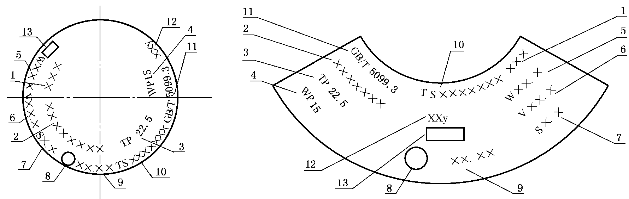

Note:

1. –Gas filled or its chemical formula;

Remark: when the mixed gas are filled, the main gas (the gas with the maximum content) or its chemical formula shall be stamped in the place of gas filled, followed by M and the characteristic letter of mixed gas. Chemical formula, M and the characteristic letter of mixed gas are separated by "-" individually. The characteristic letters of mixed gas are: T stands for toxicity, O stands for oxidation, F stands for combustion, C stands for corrosiveness, and the sequence of characteristics letters should be T, O, F, C. For several characteristics, type all letters of them, for example: XXX- M-TOFC.

1. – cylinder series number
2. – hydraulic test pressure, in MPa;
3. – nominal working pressure, in MPa;
4. – measured empty cylinder weight (not include valve and neck ring), in kg;
5. – nominal water capacity, in l;
6. – guaranteed minimum wall thickness of cylinder, in mm;
7. – manufacturer code (same as that in the record of issuing authority);
8. – manufacture year and month;
9. – manufacturer license No. of special equipment
10. – cylinder standard
11. – service life
12. – supervision and inspection mark

**Figure 11 ~~-~~ Illustration of cylinder marking**

**8.1.2 Paint color coding**

Paint color, letter font and letter color shall be applied in accordance with GB / T 7144.

**8.2 Coating**

**8.2.1** Before the cylinder is coated, the oil stain, rust and other sundries on the surface shall be removed, and the cylinder shall be coated under dry conditions.

**8.2.2** The coating shall be uniform and firm without bubble, flow mark, crack, peeling and other defects.

**8.3 Package**

**8.3.1** Packed according to user's requirements, the cylinder without valve shall be sealed by reliable technics to prevent it from contamination.

**8.3.2** The cylinder can be packed in bundles, boxes or bulk.

**8.4 Transportation**

**8.4.1** The cylinder shall be transported in accordance with the regulations of Transportation Department.

**8.4.2** During the transportation, loading and unloading, it is necessary to prevent collision, dampness and damage to accessories.

**8.5 Storage**

**8.5.1** Cylinders shall be stored in order by classification and batch. If stacking is adopted, the height shall be limited to prevent damage.

**8.5.2** Reliable measures of moisture-proof shall be taken before cylinder shipment.

**9 Product certificate and batch inspection quality certificate**

**9.1 Product certificate**

**9.1.1** Each cylinder satisfying test and inspection requirement shall be delivered to the user with a product certificate.

**9.1.2** Product certificate shall include following:

a) cylinder manufacturer;

b) cylinder serial number;

c) nominal working pressure;

d) hydraulic test pressure;

e) leak test pressure;

f) material cast No., chemical composition and guaranteed values of mechanical property;

g) heat treatment conditions;

h) guaranteed minimum wall thickness of the cylinder;

i) measured empty cylinder weight(exclude valve and neck ring);

j) measured water capacity;

k) product standard;

l) manufacture year, month;

m) manufacturer license No. of special equipment;

n) inspection mark;

o) manual.

**9.2 Batch inspection quality certificate**

**9.2.1** Each cylinder satisfying test and inspection requirement shall be delivered to user with batch inspection quality certificate. When there are many users for one batch of cylinders, all users shall have copies of batch inspection quality certificate of this batch.

**9.2.2** The contents of batch inspection quality certificate shall include inspection items specified in this document, see Appendix F.

**9.2.3** The manufacturer shall properly keep the original or copy of the inspection record and batch inspection quality certificate for at least 7 years.

**Annex A**

(informative)

**Torque of cylinder valve installation**

**A.1 Taper thread** (see Table A.1)

**Table A.1 ~~-~~ Torque of taper thread valve installation**

|  |  |  |
| --- | --- | --- |
| Thread size | Torque/(N·m) | |
| Minimum | Maximum, |
| PZ19.2 | 120 | 150 |
| PZ27.8 | 200 | 300 |
| PZ39 | 250 | 400 |
| Note: for stainless steel valve, the minimum and maximum installation torque shall be  2 / 3 of the value in this table respectively. | | |

**A.2 Straight thread** (see Table A.2)

**Table A.2 Torque of common thread valve installation**

|  |  |  |
| --- | --- | --- |
| Thread size | Torque/(N·m) | |
| Minimum | Maximum, |
| M18 | 100 | 130 |
| M25 | 100 | 130 |
| M30 | 100 | 130 |

**Annex B**

(normative)

**Ultrasonic examination**

**B.1 Scope**

This annex specifies techniques of ultrasonic examination on steel cylinder.

**B.2 General**

**B.2.1** The ultrasonic examination equipment shall be capable of detecting steel cylinder on-line automatically, at least detecting the reference standard notches described in B.4, and 100% examining of wall thickness for cylindrical part. It shall be serviced regularly in accordance with the manufacturer's operating instructions to ensure that its accuracy is maintained. It shall meet the requirement of examination standard. Inspection records and approval certificates for the equipment shall be maintained.

**B.2.2** The operation of the ultrasonic examination equipment shall be by qualified and experienced personnel certified at least to Level 1 and supervised by personnel certified at least to Level 2 who signs the test report.

**B.2.3** The inner and outer surfaces of any cylinder, which is to be examined ultrasonically, shall be in a condition suitable for an accurate and reproducible examination.

**B.2.4** For flaw detection, the pulse echo system shall be used. Either contact or immersion techniques of examination shall be used.

**B.3 Technics**

**B.3.1** The cylinders to be examined and the search unit shall have a rotating motion and translation relative to one another such that a helical scan of the cylinder will be described. The velocity of rotation and translation shall be constant to within 10 %. The pitch of the helix shall be less than the width covered by the probe (at least a 10 % overlap shall be guaranteed) and be related to the effective beam width such as to ensure 100 % coverage at the velocity of rotational and translation used during the calibration procedure.

**B.3.2** The cylinder wall shall be examined for longitudinal imperfections with the ultrasonic energy transmitted in both circumferential directions and, for transverse imperfections, in both longitudinal directions.

**B.3.3** For concave-based cylinders where hydrogen embrittlement or stress corrosion can occur, the transition region between the cylindrical part and the cylinder base shall also be examined for transverse imperfections in the direction of the base. For the area to be considered, see Figure B.1. The ultrasonic sensitivity shall be set at +6 dB to improve the detection of imperfections equivalent to 5 % of the cylindrical wall thickness in this thickened portion. When optional examination is carried out on the transition areas between the wall and neck and/or wall and base, this may be conducted manually, if not carried out automatically.

**B.3.4** The effectiveness of the equipment shall be periodically checked by putting a reference standard through the examination procedure. This check shall be carried out at least at the beginning and end of each shift. If during this check, the presence of the appropriate reference notch is not detected, all cylinders examined subsequent to the last acceptable check shall be retested after the equipment has been reset.

**B.4 Reference standard**

**B.4.1** A reference standard of convenient length shall be prepared from a cylinder which is dimensionally and acoustically representative of the cylinder to be examined, as demonstrated by the manufacturer. The reference standard shall be free of discontinuities which may interfere with the detection of the reference notches.

**B.4.2** Reference notches, both longitudinal and transverse, shall be machined on the outer and inner surface of the reference standard. The notches shall be separated such that each notch can be clearly identified.

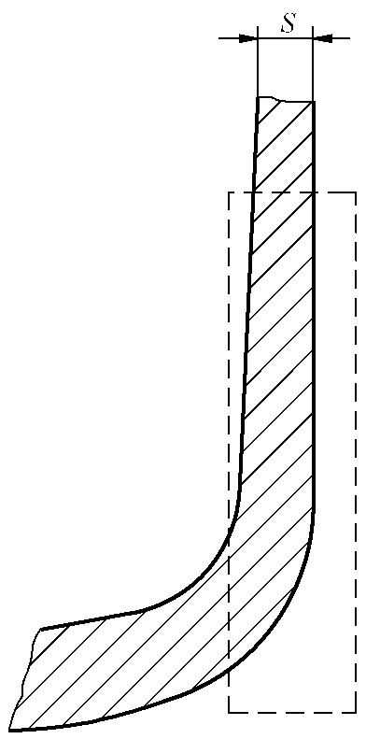

**Figure B.1 ~~-~~ Base/wall transition region**

**B.4.3** The dimensions and shape of notches are of crucial importance for the adjustment of the equipment (see Figures B.2 and B.3):

1. The length of the notches, *E*, shall not be greater than 50 mm;
2. The width, W, shall not be greater than twice the nominal depth, *T*. However, where this condition cannot be met a maximum width of 1,0 mm is acceptable;
3. The depth of the notches, *T*, shall be (5±0,75) % of the guaranteed minimum wall thickness, S, with a minimum of 0,2mm, a maximum 1mm over the full length of the notch. Runouts at each end are permissible;

d) The notch shall be sharp edged at its intersection with the surface of the cylinder wall. The cross-section of the notch shall be rectangular, except where spark erosion machining methods are employed, when it is acknowledged that the bottom of the notch will be rounded.

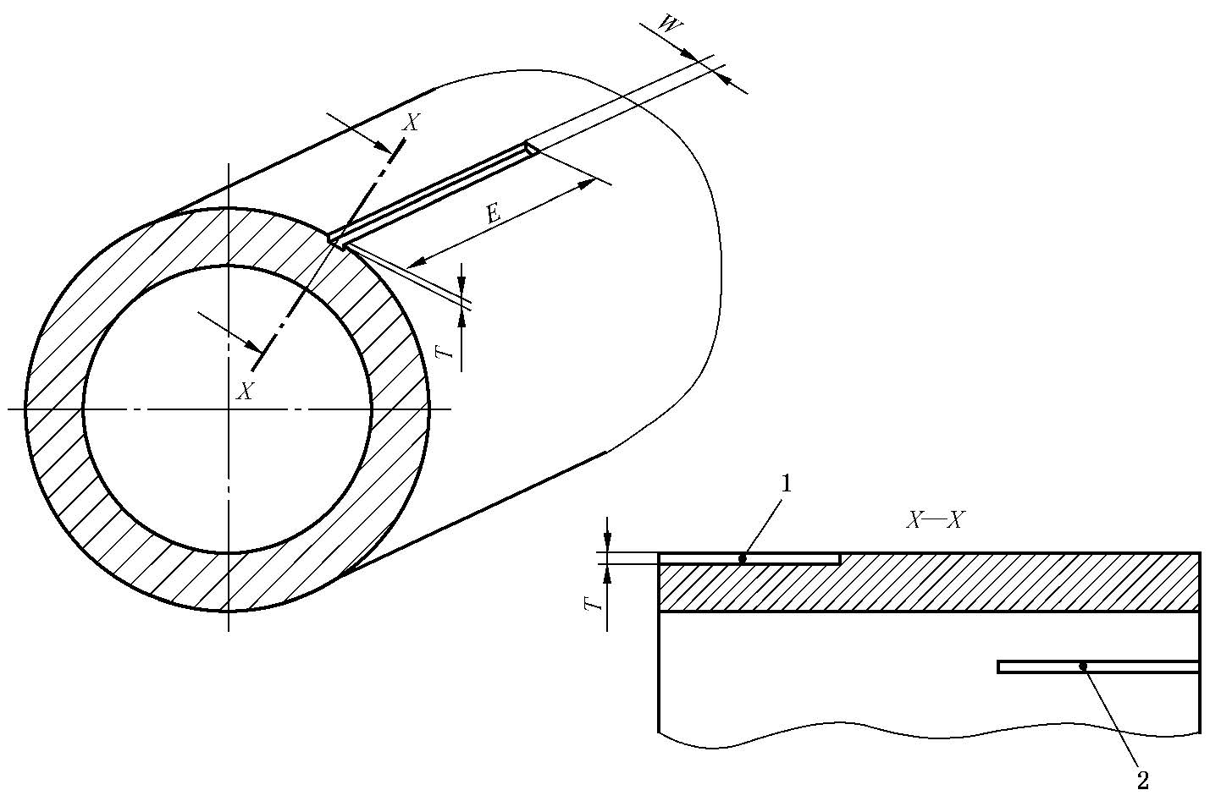

**Key**

1 outside reference notch

2 inside reference notch

Note: *T* =(5±0.75)%S, and 0.2mm≤*T* ≤1mm;

*W* ≤2*T*, where this condition cannot be met ,*W* =1.0mm; *E*≤50mm

**Figure B.2 — Design details and dimensions of the reference notches for longitudinal imperfections**

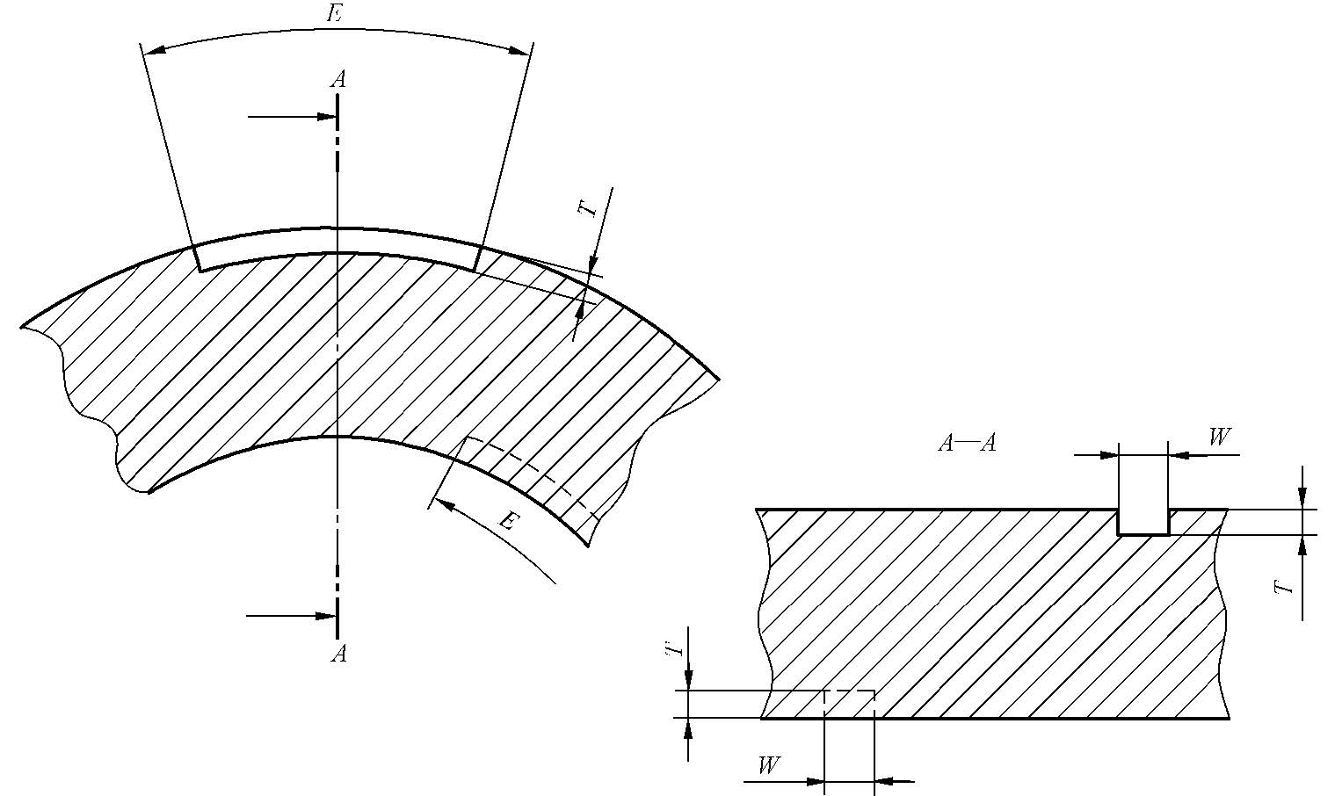

Note: *T* =(5±0.75)%S, and 0.2mm≤*T* ≤1mm;

*W* ≤2*T*, where this condition cannot be met ,*W* =1.0mm; *E*≤50mm

**Figure B.3 ~~-~~ Design details and dimensions of the reference notches for circumferential imperfections**

**B. 5 Calibration of equipment**

Using the reference standard described in B.4, the equipment shall be adjusted to produce clearly identifiable indications from inner and outer surface notches. The amplitude of the indications shall be as near equal as possible. If it is not possible to set the rejection levels individually, then the indication of smallest amplitude shall be used as the rejection level and for setting visual, audible, recording or sorting devices. The equipment shall be calibrated with the reference standard, moving in the same manner, in the same direction and at the same speed as will be used during the inspection of the cylinder. All visual, audible, recording or sorting devices shall operate satisfactorily at the test speed.

**B.6 Interpretation of results**

Cylinders with indications that are equal to or greater than the lowest of the indications from the reference notches shall be rejected. The surface defects can be removed; after removal, it is accepted only when indications are less than the lowest of the indications from the reference notches and the wall thickness is not less than the guaranteed minimum value.

**B.7 Examination report**

The ultrasonic examination report shall be issued after ultrasonic examination. The report shall accurately show the process and meet the requirements of the examination technics. It shall at least include: examination date, cylinder size, batch number, process conditions, equipment used, quantity examined, qualified quantity and unqualified quantity, operator, evaluator, description of unqualified defects, etc.

**Annex C**

(normative)

**Magnetic particle test**

**C.1 Scope**

This annex specifies techniques of magnetic particle test on steel cylinder.

**C.2 General**

**C.2.1** Circumferential and longitudinal magnetization and demagnetization shall be conducted on the cylinder by magnetic particle test equipment through continuous method with magnetic traces in all directions being displayed. The magnetic particle test equipment must be operated in accordance with an approved written procedure with required accuracy. Quality certificate or calibration certificate must be provided for magnetic particle test equipment.

**C.2.2** The operation of the magnetic particle test equipment shall be by qualified and experienced personnel certified at least to Level 1 and supervised by personnel certified at least to Level 2 who signs the test report.

**C.2.3** Continuous method shall be used for magnetic particle test. When fluorescent magnetic particle is used, the black light irradiance of the black light lamp on the cylinder surface shall be greater than or equal to 1000 μ W / cm2, and the wavelength of the light shall be 320 mm ~ 400 mm.

**C.2.4** Oil based magnetic suspension liquid or water-based magnetic suspension liquid can be used for magnetic particle test. The concentration of magnetic suspension liquid shall be determined according to the type, size, application method and time of magnetic particles. Generally, the concentration of non-fluorescent magnetic particles is 10g / L ~ 25g / L, and the concentration of fluorescent magnetic particles is 0.5g/L ~ 3g / L.

**C.2.5** Before magnetic particle test, the cylinder surface shall be completely cleaned, and free of oil stain, burr and loose oxide skin

**C.2.6** Before electromagnetization, any non-conductive substance in the contact area between the surface and the electrode shall be removed.

**C.3 Test procedure**

**C.3.1** The magnetic particle test of seamless steel gas cylinder shall be performed by wet method. The magnetic suspension liquid shall be applied at the same time of power on. During the magnetization process, the power on time is 1.5s-3s each time. The magnetization can be stopped only after the suspension liquid application is stopped. The magnetic field intensity on the surface of the cylinder shall reach 2.4 Ka/m ~ 4.8 Ka/m.

**C.3.2** The comprehensive magnetic particle test shall be performed on outer surface of the cylinder completely. The circumferential magnetic field and longitudinal magnetic field shall be applied on the cylinder, check the defects on the surface and area near the surface.

**C.3.3** The defect magnetic traces shall be observed immediately after they are formed. The magnetic traces under observation shall not be wiped off. For the magnetic traces that need further inspection, they shall be magnetized again. During inspection, it can be observed with the help of a magnifying glass.

**C.3.4** The defect magnetic trace and false defect magnetic trace should be determined according to the characteristics of the magnetic trace indicated. If it is hard to determine the magnetic trace, wipe and clean the surface after demagnetization, then conduct magnetic particle test again.

**C.3.5** At the beginning and end of each shift of magnetic particle test, A1-30 / 100 shims specified in standard JB / T6065 shall be used to verify the comprehensive performance of magnetic particle test equipment, magnetic particle and magnetic suspension liquid, and the test can only be performed when verification result is accepted. During this check, if the presence of the appropriate reference defect of shim could not be detected, all cylinders examined subsequent to the last acceptable check shall be retested after the equipment has been reset.

**C.4 Result**

Cylinder with defect magnetic trace of cracks and non-metallic inclusions on the surface shall be judged as unqualified. It is allowed for the surface defects to be removed by grinding, but the residual wall thickness after grinding shall not be less than the guaranteed minimum wall thickness. After grinding and repairing, the cylinder shall be retested.

**C.5 Demagnetization**

Demagnetization shall be performed for steel cylinder after magnetic particle test. Demagnetization can generally be measured by remanence tester or magnetic field intensity meter. Remanence shall be not greater than 0.3 mT.

**C.6 Test report**

The magnetic particle test report shall be issued after the test is completed. The test report shall be able to accurately indicate the test process and satisfy the test specification, which shall at least include: test date, cylinder size, batch number, test process conditions, equipment used, quantity, qualified quantity and unqualified quantity, test operator, personnel who makes evaluation, description of unqualified defects, etc.

**Annex D**

(normative)

**Flattening test**

**D.1 Scope**

This annex specifies a method for determination of mechanical property of steel cylinder in flattening test, which is applicable to the test of multi axial strain of steel cylinder.

**D.2 Test cylinder**

**D.2.1** The inner and outer surface quality of the test cylinder shall be inspected, and there shall be no pit, scratch, crack, lamination, folds and other defects affecting the strength, no oil stain, paint and other sundries on the surface, and the air outlet shall open completely.

**D.2.2** The measured minimum wall thickness of test cylinder shall not be less than the guaranteed minimum wall thickness value.

**D.2.3** The wall thickness of the test cylinder shall be measured. The average value of wall thickness is measured at position of A, B, C and D on the cylinder symmetrical to the axis, see Figure D.1.

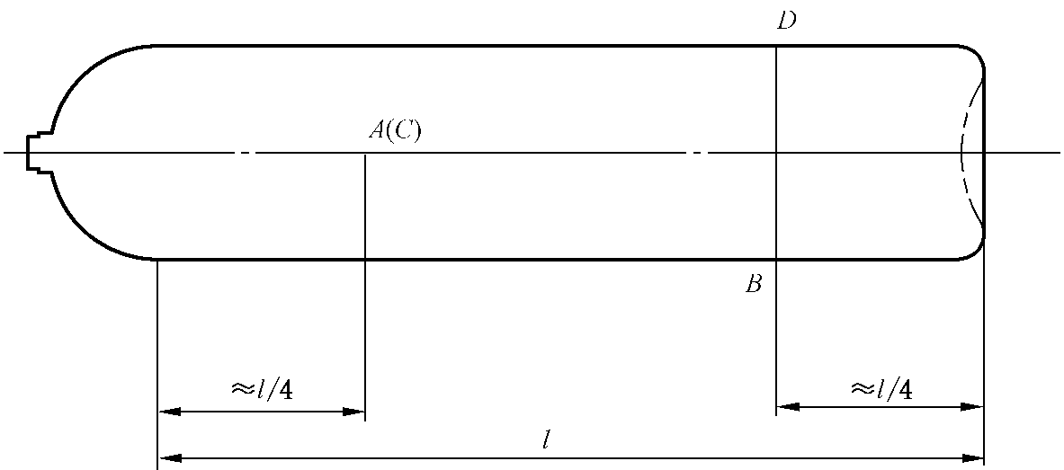

**Key**

*l* - length of cylindrical part of test cylinder

**Figure D.1 ~~-~~ Position of A, B, C and D to be measured on the cylinder**

**D.3** Test equipment

**D.3.1** Knife edges or platens

**D.3.1 .1** Materials of knife edges or platens shall be carbon tool steel or other steel with good performance.

**D.3.1.2** The machined knife edges or platens shall be heat treated, and its hardness shall not be less than HRC 45.

**D.3.1.3** Knife edges or platens shall be with a 60° included angle, rounded to a nominal radius of 13 mm. The length of knife edges or platens shall not be less than 1.5 times of the outer diameter *D* of the test cylinder, the height of knife edges or platens shall not be less than 0.5 times of the outer diameter *D* of the cylinder, the surface of the knife edges or platens shall be smooth. The shape and size of knife edges or platens, see Figure D.2

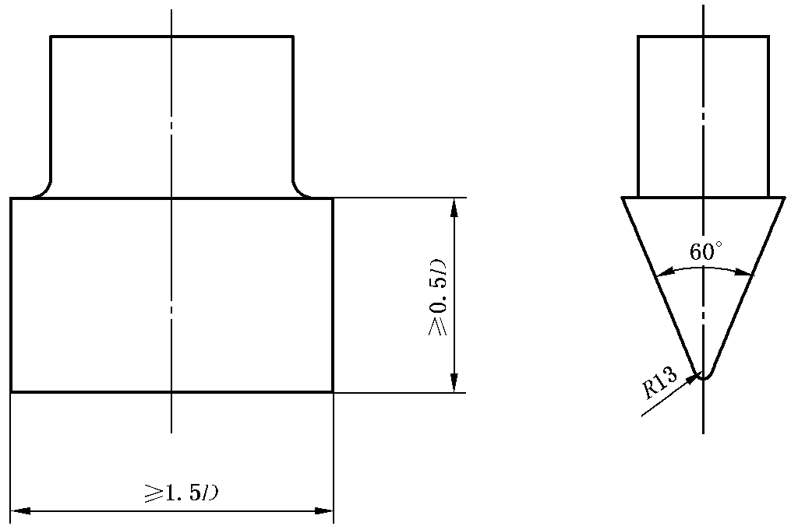

**Figure D.2 ~~-~~ Shape and size of knife edges or platens**

**D.3.2 Test machine**

**D.3.2.1** The test machine shall be calibrated by a qualified measurement and inspection department; it can be used only when it is calibrated to be qualified and within the validity period.

**B.3.2.2** The rated load of the test machine shall be 1.5 times greater than the maximum load of the flattening test.

**D.3.2.3** The test machine shall be lubricated and maintained according to the relevant regulations of equipment maintenance and repair. The test machine shall be kept clean, and the operating platform shall be free of oil, foreign matters, etc.

**D.3.2.4** The test machine shall be equipped with appropriate safety facilities to ensure the safety of operators and equipment during the test.

**B.3.2.5** The test machine shall be operated within the temperature range required.

**D.4 Procedure**

**D.4.1** The test machine shall make a dry run before operation, and all parts, instruments and meters shall be checked. The test machine can only be operated under normal conditions.

**D.4.2** Knife edges or platens shall be fixed on the jaws and the position of the upper and lower knife edges or platens shall be adjusted. During the test, the upper and lower knife edges or platens shall be in the same central plane of the plumb. The upper and lower knife edges or platens shall keep parallel movement, and horizontal movement is not allowed.

**D.4.3** Place the middle of the cylinder between two knife edges or platens perpendicular to the axis of the cylinder, as shown in Figure D.3. Then slowly turn on the valve to load at the speed of 20 mm / min ~ 50 mm / min, and apply pressure to the test cylinder until the specified distance between knife edges or platens, *T*, is reached.

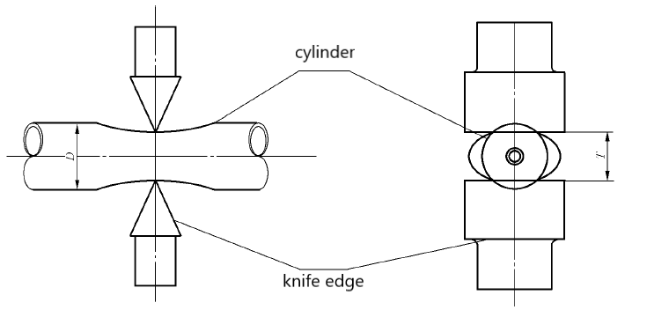

**Figure D.3 ~~-~~ Illustration of flattening test**

**D.4.4** Keep the distance between knife edges or platens, *T*, and load unchanged, visually inspect the surface condition of deformation flattened.

**D.5** Precautions in flattening test

**D.5.1** If any abnormality is found during the test, the test shall be stopped immediately. Check and make judgment, and continue the test after troubleshooting.

**D.5.2** The test machine shall be operated by a specially assigned person and recorded.

**D. 6 Test report**

The flattening test report shall be issued after the test is completed. The test report shall be able to accurately indicate the test process with traceability, which shall at least include: test date, cylinder material, size, heat treatment batch number, guaranteed minimum wall thickness, measured minimum wall thickness, average value of measured wall thickness, equipment used,

flattening rate, distance between knife edges or platens, maximum load, test result and operators.

**Annex E**

(normative)

**Description and evaluation of manufacturing imperfections and**

**conditions for rejection of seamless steel gas cylinders at time of final**

**inspection by the manufacturer**

**E.1 Scope**

This annex identifies the description and evaluation ofmanufacturing imperfection**s** of steel cylinder, which is applicable to the inspection and evaluation of manufacturing imperfections of steel cylinder.

This annex provides the evaluation method of common manufacturing imperfections for inspectors who perform the visual inspection.

**E.2 General**

**E.2.1** The inspectors shall be trained to obtain corresponding qualifications, have extensive field experience and good judgment to detect and evaluate the manufacturing imperfections of steel cylinder by means of the lighting, measuring tools and comparison of typical imperfection samples.

**E.2.2** The surface of the metal, in particular of the inner wall, should be completely clean, dry and free of oxidation products, corrosion, scale, etc., as these could obscure other more serious imperfections. Where necessary, the surface shall be cleaned under closely controlled conditions by suitable methods before further inspection.

**E.2.3** Appropriate sources of illumination with sufficient intensity shall be used.

**E.2.4** After the cylinders have been closed and the threads have been cut, the internal neck area shall be examined by means of an introscope, dental mirror or other suitable appliance.

**E.2.5** Small imperfections can be removed by local dressing, grinding, machining or other appropriate method. Great care should be taken to avoid introducing new injurious imperfections. After such a repair, the cylinders shall be re-examined and, if the cylindrical wall thickness is reduced, it shall be rechecked.

**E.3** Manufacturing imperfections

**E.3.1** The most commonly found manufacturing imperfections and their definitions are listed in Table E.1.

**E.3.2** Rejection limits for repair have been established following considerable field experience. They apply to all sizes and types of cylinders and service conditions. If the conditions of the customer are stronger than those specified in Table E.1, the customer may make an agreement with the manufacturer additionally.

**Table E.1 ~~-~~ Manufacturing imperfections**

|  |  |  |  |  |
| --- | --- | --- | --- | --- |
| **S/N** | **Imperfection** | **Description** | **Conditions for rejection and/or action** | **Repair/Reject** |
| 1 | Bulge | Visible swelling on external surface, collapsing on inner surface, and no obvious local deformation in the wall thickness | All cylinders with such an imperfection | Reject |
| 2 | Cut, gouge,  metallic or scale  impression | Imperfections caused by grinding, abrasion, peeling off of scale or other non- corrosive reasons, such as local wall thickness thinning, shallow and flat surface | When the wall thickness is less than guaranteed minimum wall thickness or  the depth of dent exceeds 5 % of the wall thickness | Reject |
| 3 | Dent (flats) | A depression in the wall which has neither penetrated nor removed metal with a depth greater than 1 % of the external cylinder diameter (see Figure E.1) | When the depth of the dent exceeds 2 % of the outer diameter of the cylinder | Reject |
| Figure E.1-Dent | | | |
| 4 | Dent containing  cut or gouge | A depression in the wall which contains a cut or gouge (see Figure E.2) | All cylinders with such imperfections | Reject |
| Figure E.2-Dent containing cut or gouge | | | |
| 5 | Damage by impact | Local deformation and reduction of wall thickness caused by impact or collision of sharp objects, small and deep pit like mechanical damage left on the surface with sharp root and raised metal around | When not removable within thickness  tolerance | Reject |
| When removable within thickness  tolerance | Repair |
| 6 | cuts | The local reduction of wall thickness caused by scratching and rubbing with sharp objects, and a linear mechanical damage with a sharp corner at the bottom is left on the surface of the cylinder | when the depth exceeds 5 % of wall thickness | Reject |
| 7 | "Orange peel"  surface | Orange peel appearance due to discontinuous metal flow | If sharp cracks are visible in the orange  peel surface | Reject |
| 8 | Pitting | Severe surface corrosion | All cylinders with such imperfections visible after shot blasting | Reject |
| 9 | Crack | Split, material separation | When not removable within thickness  tolerance | Reject |
| Not caused by material deterioration, when removable within thickness tolerance | Repair |
| 10 | Neck cracks | Appear as lines which run  vertically down the thread and across the thread faces (not to be confused with tap marks = thread machining marks; see Figure E.3) | All cylinders with such imperfections | Reject |
| **Key**  1 neck cracks  2 propagated  **Figure E.3 ~~-~~ neck cracks** | | | |
| 11 | Shoulder folds  and/or shoulder  cracks | Folding with peaks and troughs situated in the internal shoulder area, which can propagate into the threaded area of the shoulder  (see Figure E.4).  Cracks can start from folds in the internal shoulder area and propagate into the cylindrical machined or threaded area of the shoulder (see FigureE.4 for exactly where shoulder cracks start and how they propagate) | Folds or cracks which are visible as a line of oxide running into the threaded portion  shall be removed by a machining  operation until the lines of oxide are no  longer visible (see Figure E.4). After machining, the whole area shall be re-inspected carefully and the wall thickness verified | Repair, if  possible |
| If folding or lines of oxide have not been  removed by machining, if cracks are always visible or if wall thickness is  unsatisfactory | Reject |
| Folds which extend beyond the machined area and are clearly visible as open depressions where no oxides have been trapped into the metal, shall be accepted provided that the peaks are smooth and the root of the depression is rounded | Acceptable |
| Key  1 Shoulder cracks  2 Shoulder folds  3 propagated cracks in the shoulder  **Figure E.4- Cylinder shoulder folds or cracks** | | | |
| 12 | Internal cracks in base | Splits in the metal of the bottom of the cylinder in star form | When not removable within thickness  tolerance | Reject |
| when removable within thickness tolerance | Repair |
| 13 | Rib | A longitudinal raised surface with sharp corners(see Figure E.5) | When height  exceeds 5 % of wall thickness or when  length exceeds 10 % of the length of the  cylinders | Repair |
| **Figure E.5 ~~-~~ Rib** | | | |
| 14 | Groove | A longitudinal notch(see Figure E.6) | When depth  exceeds 5 % of wall thickness or when  length exceeds 10 % of the length of the  cylinders | Repair |
| **Figure E.6 ~~-~~ Groove** | | | |
| 15 | Lamination | Layering of the material within the cylinder wall and sometimes appearing as a discontinuity, crack lap or bulge at the surface. It is a crack defect caused by metallurgical or manufacturing reasons, but its root is not as sharp as the crack, and its starting layer is mostly parallel or slightly inclined to the surface of cylinder, also known as delamination (see Figure E.7) . | When not removable within thickness tolerance | Reject |
| When removable within thickness  tolerance | Repair |
| **Figure E.7 ~~-~~ Lamination** | | | |
| 16 | Internal neck  threads damaged  or out of tolerance | Neck threads damaged, with  dents, cuts, burrs or out of  tolerance | If it satisfies the design, threads may be re-tapped and re-checked by the appropriate thread gauge and carefully visually re-examined. The appropriate number of effective threads shall be guaranteed | Repair |
| If not reparable | Reject |
| 17 | Neck ring not  secure | Neck ring turns under application of low torque, or pulls off under low axial load | All cylinders presenting such an imperfection | Repair possible  according to  approved method  only |
| 18 | Arc or torch burns | Partial burning of the cylinder metal, the addition of weld metal or the removal of metal by scarfing or cratering | All cylinders presenting such imperfections | Reject |

**E.4** Rejected cylinders can be used to produce cylinders for different service conditions (such as reducing the working pressure level), but relevant technical documents are required. When it is not possible to produce cylinders for different service conditions from rejected cylinders, all rejected cylinders shall be rendered unserviceable for their original application by cutting, flattening and other methods.

**Annex F**

(normative)

**Quality certificate for batch inspection of seamless steel gas cylinder**

No.:

Type of cylinder Designation or type of gas

Manufacturer Manufacturer license No. of special equipment

Cylinder drawing No.

Base structure Concave end □ Hot forming end □ Convex end □

H – shape end □ Double opening end □

Batch No. Manufacture date

Quantity of this batch: , from No. to No.

|  |
| --- |
| Remark: the following cylinder numbers are not included in this batch of qualified cylinders: |

**F. 1 Technical data**

Nominal water capacity l Nominal working pressure MPa

Nominal outside diameter mm Hydraulic test pressure MPa

Guaranteed min. wall thickness mm Leak test pressure MPa

**F.2 Material compositions** (mass fraction)

|  |  |  |  |  |  |  |  |  |
| --- | --- | --- | --- | --- | --- | --- | --- | --- |
| Cast No. | C | Mn | Si | S | P | S+P | Mo | Cr |
|  |  |  |  |  |  |  |  |  |
| Criterion |  |  |  |  |  |  |  |  |

**F.3 Mechanical property after heat treatment**

Heat treatment method

Guaranteed min. value of the yield strength after heat treatment, *R*e MPa

Guaranteed min. value of the tensile strength after heat treatment, *R*g MPa

|  |  |  |  |  |
| --- | --- | --- | --- | --- |
| Test cylinder No. | *R*ea /MPa | *R*m /MPa | *A*/% | *a*kV /(J·cm-2) |
|  |  |  |  |  |

**F.4 Base check**

There is no shrinkage, bubble, incomplete fusion, crack, lamination and other defects. The structure, shape and size satisfy the drawing.

**F. 5 Hydraulic burst test**

Test cylinder serial No.

Observed pressure when cylinder starts yielding MPa

Measured burst pressure MPa

Fracture: no brittle and fragment, burst profile satisfy this part of GB /T 5099.

This is to certify that the cylinders covered by this Quality certificate have passed the inspection and tests as required in GB /T 5099.3 – 2017, and they are in full accordance with this part of GB /T 5099 and the certified design-type approval.

Independent Inspection Agent(stamp)： Manufacturer(inspection stamp):

Inspector: Responsible inspector from manufacture

Year month date Year month date