
ICS 23.020.30
J 74

中华人民共和国国家标准
GB/T 32556—2016

Welded stainless steel cylinders
（ISO 18172-1:2007，Gas cylinders—Refillable welded stainless steel cylinders—Part 1:Test pressure 6MPa and below，NEQ）

2016-02-24发布
2016-09-01实施
国家质量监督检验检疫总局 发布

Contents
Forword Ⅱ
1 Scope 1
2 Normative references 1
3 Terms and definations 1
4 Materials 3
5 Design 3
6 Constrution and workmanship 4
7 Tests 12
8 Batch tests 14
9 Type test 15
10 Markings 16
11 Certificate 17Annex A (normative) Color mark 18
Annex B (normative) Product certificates 21
Annex C (normative) Examples of design and batch testing certificates 24
Bibliography 26

Foreword
Chapter 3, 6.2.2, 6.5.2, 6.12.1, 8.3.3.2, 9.2.1, 10.1, Appendix B and Appendix C of this standard are recommended, the rest are mandatory.
This standard is drafted according to the rules given in GB / T 1.1-2009.
This standard is formulated by reference ISO 18172-1:2007《Gas cylinders — Refillable welded stainless steel cylinders —Part 1:Test pressure 6 MPa and below》，The degree of consistency is not equivalent with ISO 18172-1:2007.
Note that some contents of this document may involve patents. The issuing authority of this document is not responsible for identifying these patents.
本标准由全国气瓶标准化技术委员会（SAC/TC 31）提出并归口。
本标准负责起草单位：宁波美恪乙炔瓶有限公司。
本标准参加起草单位：常州蓝翼飞机装备制造有限公司；北京天海工业有限公司；
上海容华高压容器有限公司；宁波明欣化工机械有限责任公司；宜兴北海封头有限公司。
本标准主要起草人：王竞雄、叶勇、张保国、裘维平、游卓华、魏东琦。

Welded stainless steel cylinders
  - Scope
This part specifies minimum requirements concerning material, design, construction and workmanship, manufacturing processes, testing, Marking, packaging, transportation and storage of welded stainless steel gas.
This part of cylinders used at -40℃～60℃, and water capacities from 0,5 l up to and including 1000 l, for compressed, liquefied and dissolved gases. It is applicable only to cylinders manufactured from stainless steels with test pressures up to 6 MPa (60 bar).
  - Normative references
The following referenced documents are indispensable for the application of this document. For dated references, only the edition cited applies. For undated references, the latest edition of the referenced document (including any amendments) applies.
GB 150.3 Pressure vessel /part 3：design
GB/T 228.1 Tensile test of metallic materials /part1： Room temperature test method
GB/T 232 Test method for bending of metallic materials
GB/T 1804 general tolerance/Tolerances for linear and angular dimensions without tolerance indications
GB/T 4334-2008 Corrosion of metals and alloys/Test method for intergranular corrosion of stainless steel
GB/T 7144 Colored cylinder mark for gases
GB 8335 Special threads for gas cylinders
GB/T 9251 Methods for hydrostatic test of gas cylinders
GB/T 9252 Methods for pressure cycling test for gas cylinders
GB/T 12137 Methods for leakage test of gas cylinders
GB/T 13005 Gas cylinders-Terminology
GB/T 14976 Seamless stainless steel pipes for fluid transport
GB/T 15384 Designation for gas cylinders
GB/T 15385 Method for hydraulic burst test of gas cylinders
GB/T 16163 Classification of gases filled in cylinder
GB/T 17925 Standard practice for X-ray digital radioscopic examination of cylinder weld
GB 24511 Stainless steel and heat resisting steel plate, sheet and strip for pressure equipments
NB/T 47013.2 Nondestructive testing of pressure equipments-part 2: Radiographic testing
  - Terms and definitions
    - definitions
The following terms and definitions defined in GB / T 13005 are applicable to this document.

batch
quantity of cylinders made consecutively by the same manufacturer, using the same manufacturing techniques, to the same design, size and material, from the same cast on the same type of welding machines and welding procedures.

yield stress
value corresponding to 0,2 % proof stress (R p0,2 ) or, for austenitic steels in the solution annealed condition.

design stress factor
ratio of equivalent wall stress at test pressure (p h ) to guaranteed minimum yield stress (R e )
    - Symbols
The following symbols apply to this document.
a: calculated minimum thickness, in mm, of the cylindrical shell (mm).
A: percentage elongation after fracture (%).
b: Butt joint misalignment of weld (mm).
c: shape factor of dished ends (mm).
d: Diameter of bending shaft for bending test (mm).
D: Nominal diameter of cylinder (mm).
D_{i}: diameter of former, in mm.
D_{o}: outside diameter, in mm, of the cylinder.
e: Maximum and minimum diameter difference of the same cross section of cylinder (mm).
E: Edge height of butt weld (mm).
F: design stress factor.
h:height, in mm, of the cylindrical part of the end (mm).
H_{i}: outside height, in mm, of the domed part of the end (mm).
K: Head shape factor.
l: Template length (mm).
L: length, in mm, of the cylinder.
n: ratio of diameter of bend test former to the thickness of the test piece.
P: Nominal working pressure in MPa (bar)
P_{b}: measured burst pressure, in MPa (bar) , above atmospheric pressure, in the burst test。
P_{h}: hydraulic test pressure, in MPa (bar), above atmospheric pressure。
P_{y}: observed yield pressure, in MPa (bar), above atmospheric pressure。
r: inside radius of the knuckle end, in mm.
R_{p0.2}: minimum value of 0,2 % proof stress, in MPa, guaranteed by the cylinder manufacturer for the finished cylinder
R_{i}: Inner radius of spherical part of head , in mm
R_{m}: actual value of tensile strength, in MPa, determined by a tensile test
R_{ma}: Measured tensile strength，in MPa
S: Design wall thickness of bottle body, in mm
S₁: Design wall thickness of cylinder, in mm
S₂: Design wall thickness of head, in mm
S_{b}: Measured minimum wall thickness of bottle, in mm
S_{h}: actual thickness of the test specimen, in mm
S_{k}: Weld width of tensile specimen, in mm
S_{n}: Nominal wall thickness of bottle, in mm
V: Nominal volume, in L
△H_{i}: Height in head（H_{i}+h）tolerance, in mm
φ: Coefficient of welded joint
π△D_{i}: Tolerance of inner circle circumference , in mm
  - Materials
    - General
      - material used for manufacturing the bottle body shall be nickel chromium austenitic stainless steel，and shall conform to GB 24511 or GB 14976.
      - Grades of steel used for the cylinder manufacture shall be compatible with the intended gas service. There is a risk of sensitization to intergranular corrosion resulting from the hot processing of austenitic and duplex stainless steels，If any heat treatment was done during manufacturing, an intergranular corrosion test shall be carried out.
      - All parts welded with the bottle body shall be made of materials suitable for the material properties of the bottle body，And meet the requirements of corresponding standards.
      - All parts welded to the cylinder shall be made of compatible material with respect to the weld-ability，The tensile strength of the welded joint shall not be lower than the lower limit of the specified value of the tensile strength of the base metal and shall not be lower than the specified value of the design drawing.
      - The cylinder manufacturer shall obtain and provide material certificates of the ladle analysis from the steel manufacture of the steel supplied for the construction of the pressure-retaining parts of the cylinder and for the welding consumables。
      - The chemical composition of stainless steel plate shall be rechecked according to the heat number, and the mechanical properties shall be rechecked according to the batch number. Material mark shall be made for materials qualified in re inspection, The mark shall be written with a chlorine free and sulfur free marker.
      - The migration number of materials (including welding materials) shall be recorded on the corresponding product quality record.
      - Materials shall be classified according to steel grade and stored indoors. Strict isolation measures with carbon steel.
    - Chemical composition and mechanical properties
The chemical composition and mechanical properties of the bottle material shall meet the requirements of GB 24511 or GB 14976.
When selecting overseas brand materials, the brand similar to the chemical composition and mechanical properties listed in GB 24511 or GB 14976 shall be selected. The technical requirements shall not be lower than the requirements of the corresponding brand listed in the material standard.
  - Design
    - General requirements
      - The internal pressure upon which the calculation of gas cylinders is based shall be the test pressure.
      - For calculation purposes, the value of the yield stress R_{p0.2} is limited to a maximum of 0,85 Rm.
      - The composition of the bottle body shall not exceed three parts at most, that is , there shall be no more than one longitudinal welding joint and no more than two circumferential welding joints.
      - The shape of head shall be oval[see Figure 1a)], dish [Figure 1b)]or hemispherical, and the height of the straight edge of the head, h, is specified as follows：
for oval [see Figure 1a)], H_{i}≥0.192 D_{i}，h≥4 S₂；
for dish [Figure 1b)], R_{i}≤D_{i}，r≥0.1 D_{i}，h≥4 S₂。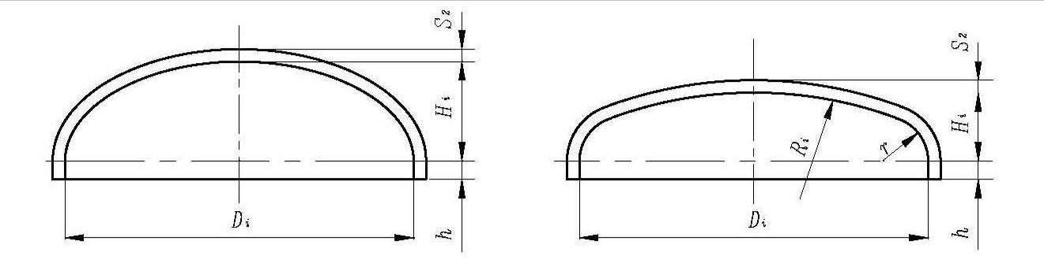
a） b）

Figure 1, Schematic diagram of the shape of the head

      - The representation of cylindershall be in accordance with GB/T15384.
    - Wall thickness of the bottle body
5.2.1 The design wall thickness,S₁,of cylinder shall keep one decimal place and not be less than that calculated using formula (1)

$S_{1}=\frac{\text{Di}}{2}\left[1−\sqrt{\frac{F×φ×R_{p0\text{.}2}−\sqrt{3}×P_{h}}{F×φ×R_{p0\text{.}2}}}\right]$ （1）
where
F=0.77 as design stress factor
φ=1 for cylinders with one circumferential weld or longitudinal welds for 100% radiographic inspection
φ=0.9 for cylinders with longitudinal welds for local radiographic inspection

The method and testing requirements for radiographic inspection of welded joints are in accordance with 6.4.

      - The design wall thickness, S2, of head shall keep one decimal place and not be less than that calculated using formula (2)
S₂ = S₁×K （2）
where
S₁ is wall thickness whose value shall be calculated using formula (1) whenφ=1.0
K is a head shape factor whose value is 1 for Hi=0.25Di, and the values of other heads shall be obtained from the curves given in Figure 2 or Figure 3
      - The minimum design wall thickness of cylinder S1 and of head S2 should meet the following requirements, as appropriate:
for Di≤100mm，S₁min=S₂min=1.1mm；
for 100mm＜Di≤150mm，S₁min=S₂min=1.1+0.008（ Di-100 ）mm；
for Di＞150mm，S₁min=S₂min= Di/250 +0.7mm and shall not less than 2.0mm。
      - The nominal wall thickness of cylinder and of head shall be equal, and when determining the nominal wall thickness of cylinder, the corrosion allowance, thickness tolerance and process reduction shall be considered.

5.3 Degign of popenings

5.3.1 No openings are allowed in the cylinder, and all openings in the head should be restricted within the range of an imaginary cylinder with the head axis as the axis and the diameter is 80% of the head diameter.

5.3.2 Each opening in the cylinder shall be reinforced by reinforce methods and calculations in accordance with GB 150.3 or finite element analysis, and the reinforcing material should be compatible and weldable with the cylinder.
  - Construction and workmanship
    - General
      - Both longitudinal and circumferential butt welds shall have full penetration.
      - Permanent backing strips shall not be used with longitudinal welds.
      - Circumferential welds are allowed to adopt permanent backing strips or bottom-locking of one respect reducing insert joint.
      - The production shall manufacture in batches.
      - Each production process shall prevent surface damage, iron ion and other impurities during the manufacturing.
      - Steel seal shall not be printed on cylinder.
    - Welding procedures
      - Before proceeding with the production of a given design or change of the cylinder material, welding material and welding process, the manufacturer shall qualify all welding procedures. Different structural welding joints (longitudinal, circumferential and fillet joint) shall be evaluated separately; each type of cylinder with wall thickness shall be evaluated, and the evaluation results of smaller diameter cylinders can cover large ones with the same wall thickness.
      - The welding procedure qualification of longitudinal welding joint can be carried out on the welding qualification test plate；The welding procedure qualification of circumferential welding joint shall be carried out on the steel cylinder or simulated cylinder test piece with the same structural form of welding joint；The welding position of fillet joint qualification shall be consistent with the actual welding position of the product。n addition to meeting the requirements of this standard, welding procedure qualification shall also meet the requirements of corresponding standards.
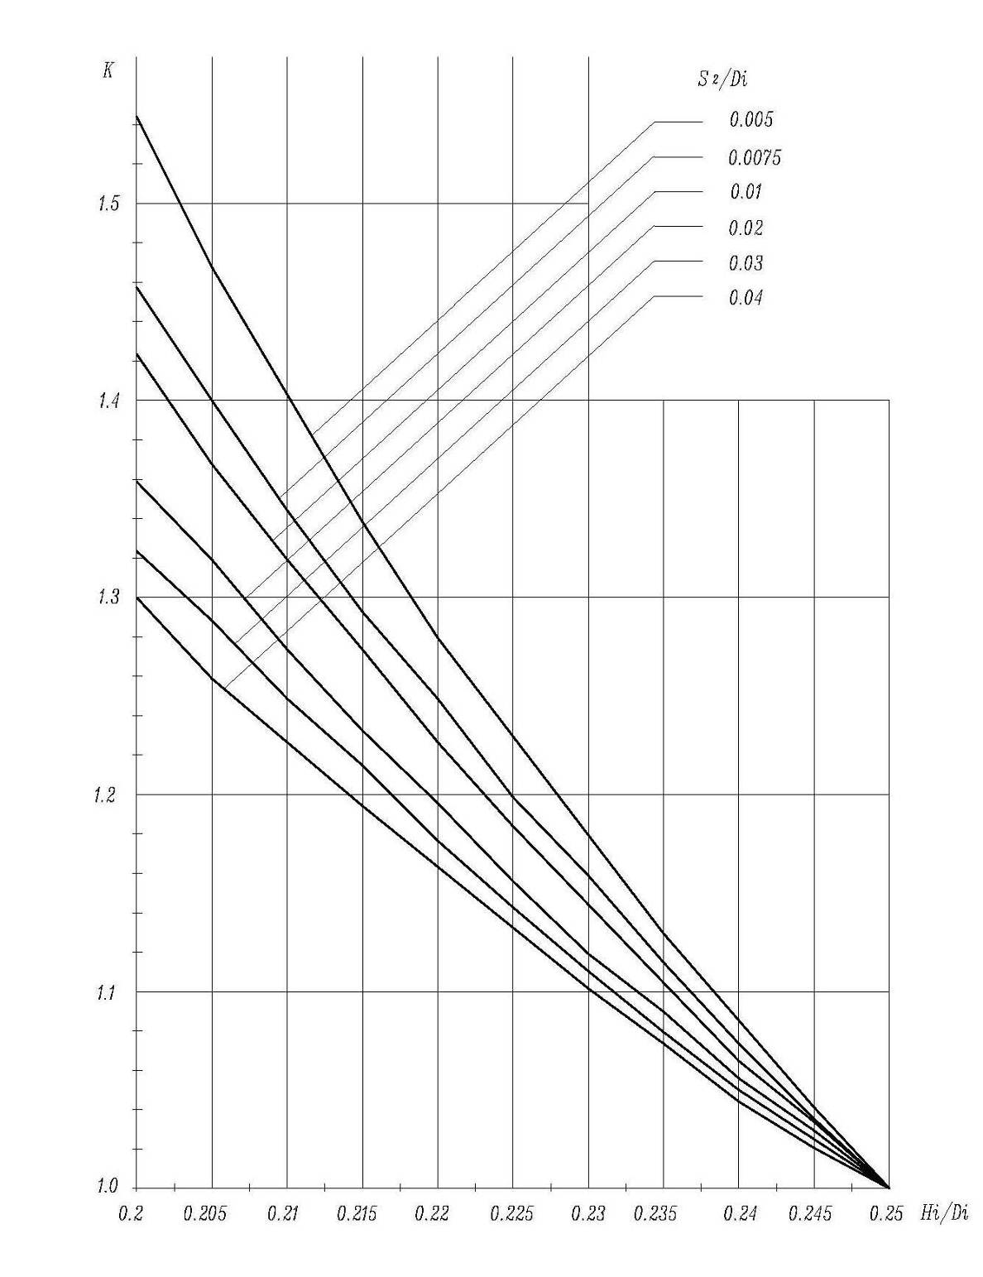
Figure 2  Values of shape factor C for H/D between 0.2 and 0.25

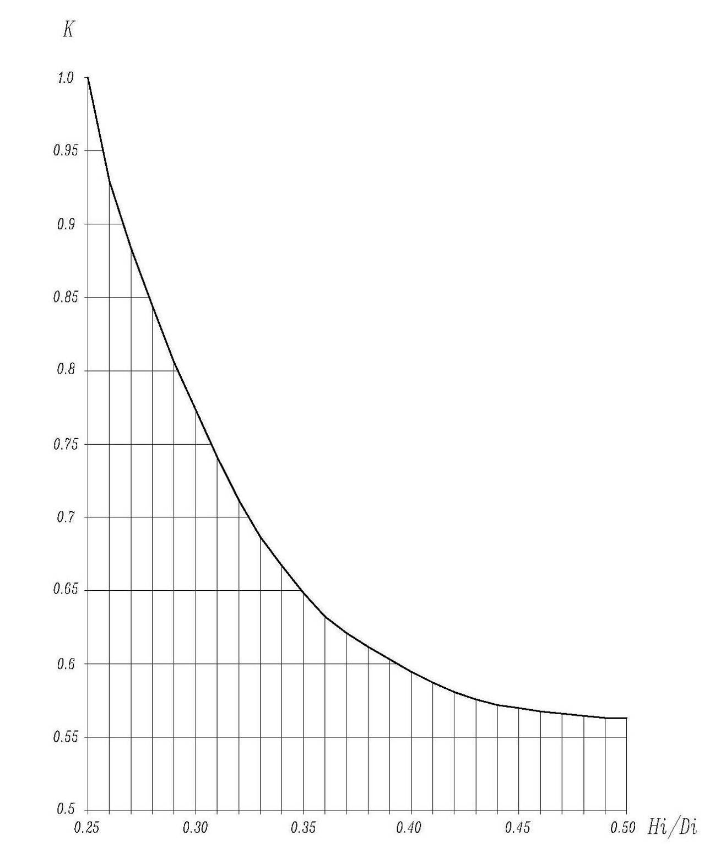
Figure 3  Values of shape factor C for H/D between 0.25 and 0.5
      - The welding procedure qualification test plate of butt weld shall be subject to visual inspection and 100% radiographic inspection，The test results shall meet the requirements of 6.3 and 6.4，The fillet weld test piece shall be subject to visual inspection and meet the requirements of 6.3.
      - The specimens of butt weld shall be subject to tensile and bending tests，The fillet weld sample shall be subject to low-power metallographic inspection。
      - The fabrication of butt weld sample shall be in accordance with 6.14.
      - Manufacture of fillet weld specimen cut 4 specimens equally from the specimen (generally the tube plate fillet weld specimen)，One of the cuts shall be at the beginning and end of the lap joint of the weld，Take one surface of each sample for low power metallographic inspection，Any two inspection surfaces shall not be two sides of the same incision。
      - The requirements for welding procedure qualification test results are as follows：
a） The mechanical property test results of welded joints shall meet the requirements of 6.14；
b) Metallographic inspection: the root of weld should be fully welded，Weld metal and heat affected zone shall be free of cracks and incomplete fusion.
      - The welding procedure qualification document shall be approved by the technical director of the gas cylinder manufacturer.
    - General provisions for welding
      - The welding work of steel cylinder shall be undertaken by the welder with certificate. There shall be traceable marks or records after welding.
      - The welding of the main body of the cylinder and the welding between the valve seat and the cylinder body shall adopt the mechanized welding or automatic welding method，And strictly abide by the qualified welding process.
      - The shape and size of welding groove shall meet the requirements of design documents，The groove surface shall be clean, smooth and free of defects such as crack and inclusion。
      - The relative humidity of cylinder welding (including welding repair) shall not be more than 90% and indoor operation with temperature not lower than 0 ℃，Otherwise, measures should be taken.
      - Do not strike arc at non welding position during welding，The longitudinal joint shall be provided with arc striking plate and arc extinguishing plate，The arc striking and extinguishing plates shall be removed by cutting，Knocking should not be used，The cut should be ground flat.
      - The weld reinforcement of the butt joint of the bottle body is 0-3mm ，The difference between the widest and narrowest parts of the same weld shall not be more than 3mm.
      - The weld geometry of the fillet joint of the valve seat and plug seat shall be smoothly transferred to the base metal surface.
      - No undercut is allowed for the weld on the bottle body，There shall be no cracks, air holes, craters, depressions and irregular abrupt changes on the surface of weld and heat affected zone，Spatter on both sides of the weld shall be removed.
    - Radiographic examination of welded joints
      - Personnel engaged in cylinder X-ray or X-ray digital imaging inspection shall have valid qualification certificate.
      - Steel cylinder designed with welded joint coefficient φ = 1，The longitudinal and circumferential welded joints of each cylinder shall be subject to 100% RT. When adopting welded joint coefficient φ = 0.9 for design and for cylinders with only one circumferential joint，According to the first piece produced by each machine in each shift and the next 50 pieces produced in sequence, one piece shall be taken (if less than 50 pieces, one shall also be taken) for radiographic inspection of the whole length of the welding joint；For cylinders with one longitudinal joint and two circumferential joints, the longitudinal and circumferential welded joints of each cylinder shall be subject to radiographic inspection of not less than 20% of the length of the joint.
      - The radio graphed parts shall include the joint of longitudinal and circumferential welding joints。
      - The radiographic testing of welded joints shall be carried out according to Nb / T 47013.2, and the technical level of radiographic testing is AB；For the X-ray digital imaging test, it shall comply with the provisions of GB/ T 17925. The quality grade of welding joint shall not be lower than grade II.
      - The quality of butt joint of bottle body without radiographic inspection shall also meet the requirements of 6.4.4.
    - Welding repair
      - Welding repair shall be carried out according to the qualified repair process，The repaired parts shall be re inspected as per 6.3 and 6.4 for appearance and radiographic inspection.
      - The repair times of the same part of the weld should not exceed twice，In case of exceeding, each repair shall be approved by the technical director.
      - The repair times and parts shall be recorded in the product production inspection records and indicated in the product certificate.
    - Cylinder body
      - When the cylinder is welded by steel plate, the rolling direction of the steel plate shall be consistent with the circumferential direction of the cylinder.
      - Maximum and minimum diameter difference of the same cross section of the cylinder id e ≤0.01D.
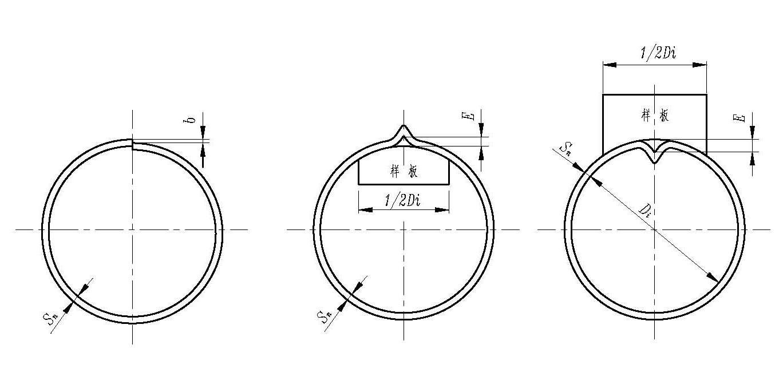
Figure 4 Schematic diagram of misalignment of longitudinal joint of cylinder Figure 5 Schematic diagram of edge height of longitudinal joint of cylinder

      - Unfitness of butt joint of longitudinal welding joint of cylinder is b ≤0.1Sn.（Figure 4）.
      - Edge height of longitudinal welded joint of cylinder is E ≤0.1Sn+2mm（Figure 5）. Measure with a sample plate with a length L of 0.5Di but not more than 300mm.
    - Head
      - The head shall be made of a whole steel plate.
      - The tolerance of the shape and dimension of the head shall not exceed that specified in Table 1，See Figure 6 for symbols.
Table 1 tolerance list of head shape and dimension mm
Nominal diameter  D | Circumference tolerance  πΔD_{i} | Maximum and minimum diameter difference  e | Surface concavity  c | Surface to template gap  a | Internal height tolerance  ΔＨ_{i}
≤200 | ±2 | 1 | 0.8 | 1.5 | + 5  - 3
＞200～400 | ±4 | 2 | 1 | 2 | + 5  - 3
＞400～700 | ±6 | 3 | 2 | 3 | + 5  - 3
>700 | ±9 | 4 | 3 | 4 | + 5  - 3

      - The measured minimum wall thickness of the head shall not be less than the sum of the head design wall thickness and corrosion allowance.
      - The straight edge of the head shall be free of wrinkles.
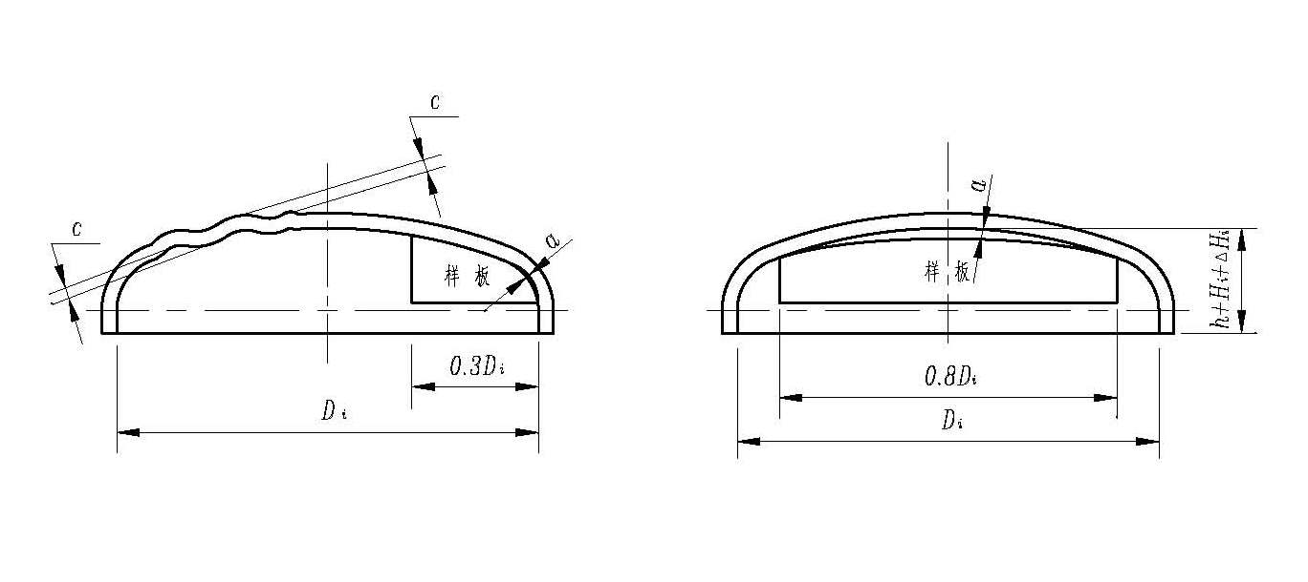
Figure 6 Schematic diagram of head shape and dimension tolerance
    - Limit deviation of dimension without tolerance
The limit deviation of linear dimension without tolerance shall be in accordance with GB / T 1804, and the specific requirements are as follows：
a）Machined parts shall not be lower than grade M；
b）Non machined parts shall not be lower than grade V.
    - Assemble
      - All parts of the cylinder shall pass the inspection before assembly, and it is not allowed to conduct strong assembly.
      - The unfitness of butt joint B and edge height e of butt circumferential welded joint between head and barrel shall not exceed the provisions of Table 2，The length of inspection ruler shall not be less than 300 mm.
Table 2 list of requirements for misalignment and edge height of longitudinal and circumferential joints of bottle body mm
Nominal wall thickness of cylinder body S_{n} | Unfitness of butt joint  b | Angular height  E
< 6 | 0.25 S_{n} | 0.10 S_{n} +2
6～10 | 0.20 S_{n} | 0.10 S_{n} +2
>10 | 0.10 S_{n} +1 | 0.10 S_{n} +2

      - When the cylinder is composed of two parts, the straightness tolerance of the cylinder part shall not be greater than 0.2% of its length.
      - When assembling and welding the bottle body and the base, the deviation between the center line of the bottle body and the vertical line of the ground shall not be greater than 1% of the length of the bottle body.
    - surface quality
The outer surface of the cylinder shall be smooth and free from cracks, double skin, inclusions and other defects affecting the use. Local defects are allowed to be polished，However, the wall thickness after grinding shall not be less than the sum of design wall thickness and corrosion allowance, and shall be smooth transition.
    - heat treatment
      - The head shall be subject to solution treatment after hot working and forming, and the specification of solution treatment shall be in accordance with the corresponding material standard and the qualified process.
      - Unless otherwise specified in the drawing, the cylinder is not subject to overall heat treatment 。
      - All heat treatment shall be recorded and kept.
    - Volume and weight
      - The measured water volume of the cylinder shall not be less than its nominal volume，For cylinders with a nominal volume greater than 150L，The measured volume can be replaced by the theoretical calculated volume, but there shall be no negative deviation.
      - After manufacturing, the net weight shall be measured one by one.
    - Pressure test and air tightness test
      - The pressure test shall be carried out one by one after the welding joint passes the radiographic inspection.

Hydrostatic test or pneumatic test shall be adopted for pressure test. The test pressure is 1.5 times of the nominal working pressure.

The chloride ion content of water used for hydrostatic test shall not exceed 25mg / L, and the pressure maintaining time under hydrostatic test pressure shall not be less than 30s. The cylinder shall be free of macroscopic deformation, leakage, abnormal sound and other phenomena, and the pressure gauge shall not drop back.Dry the bottle immediately after hydrostatic test.

The air pressure test medium shall be dry oil-free air or nitrogen. The air pressure test shall have effective safety protection measures, strictly control the pressure rise speed, and step by step increase the pressure to the test pressure. Pressure maintaining under test pressure shall not be less than 10s.
      - The cylinder air tightness test shall be conducted after the pressure test is qualified，The air tightness test pressure is the nominal working pressure. Keep the pressure under the test pressure for at least 1 min, and the tested cylinder shall be free of leakage.
      - If leakage is found on the welded joint during the water pressure test and air tightness test, it shall be repaired according to the provisions of 6.5. Carry out water pressure test and air tightness test again after repair.
    - Mechanical property test、Corrosion test、Hydraulic burst test、Pressure cycling test
      - For the steel cylinder with nominal volume less than or equal to 150L, the mechanical property test shall be carried out according to the batch sample cylinder, and the steel cylinder used for the test shall be qualified through the radiographic inspection.
      - For cylinders with a nominal volume greater than 150L, the mechanical property test shall be carried out by welding test plates or sampling cylinders of the batch products.
      - When the mechanical properties and corrosion test are carried out on the cylinder body, for the cylinder composed of two parts, the test sampling position is as shown in Figure 7，For the cylinder composed of three parts, the sampling position of the sample is as shown in Figure 8.

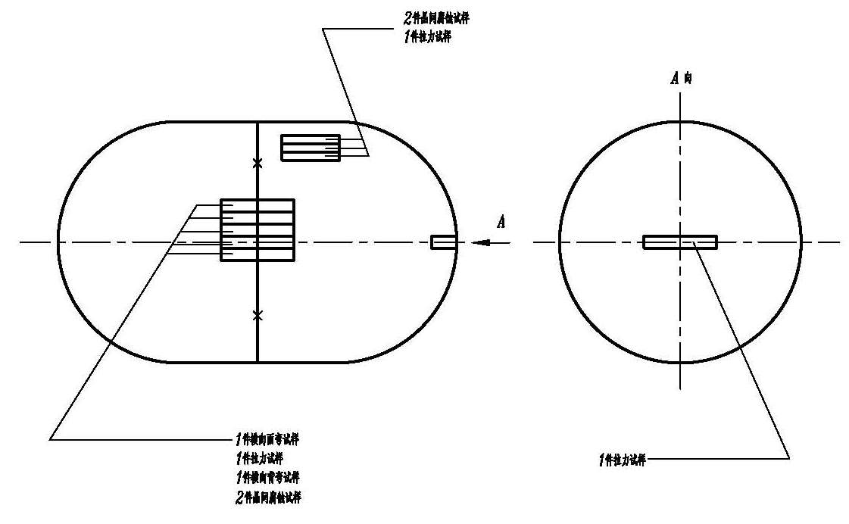
notes：X represents weld.
Figure 7 — Test pieces from two-part cylinders
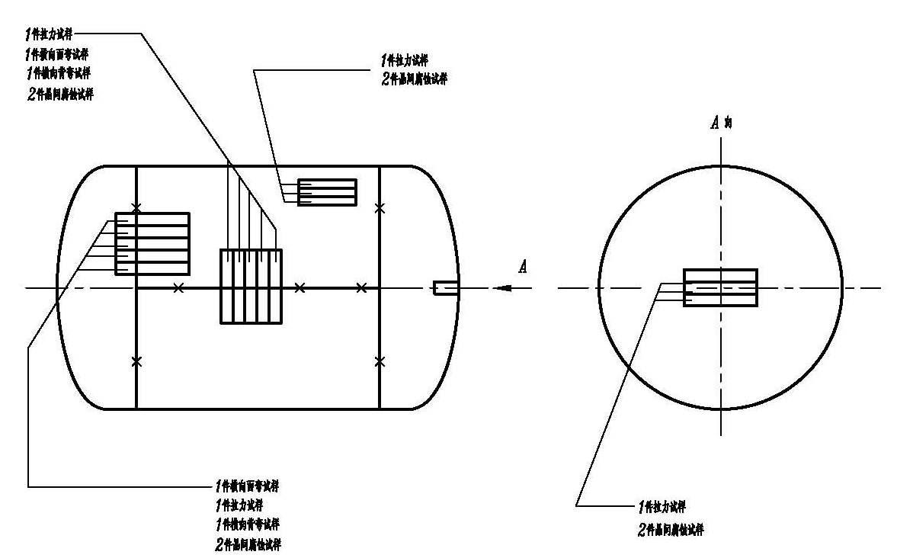
notes：X represents weld.
Figure 8 — Test pieces from three-part cylinders

      - During the mechanical properties and corrosion test of the welding test plate, the product welding test plate shall be loaded and unloaded on the same steel plate (or the same batch of steel plates) with the cylinder with the test plate. The extension part of the cylinder longitudinal weld is welded together with the longitudinal weld, and the cylinder number and welder code steel seal of the cylinder shall be marked on the test plate. The welded joint of the test plate shall be subject to visual inspection and 100% radiographic inspection, and shall meet the requirements of 6.3 and 6.4. The sampling position of the sample on the welding test plate shall be in accordance with figure 9.
mm
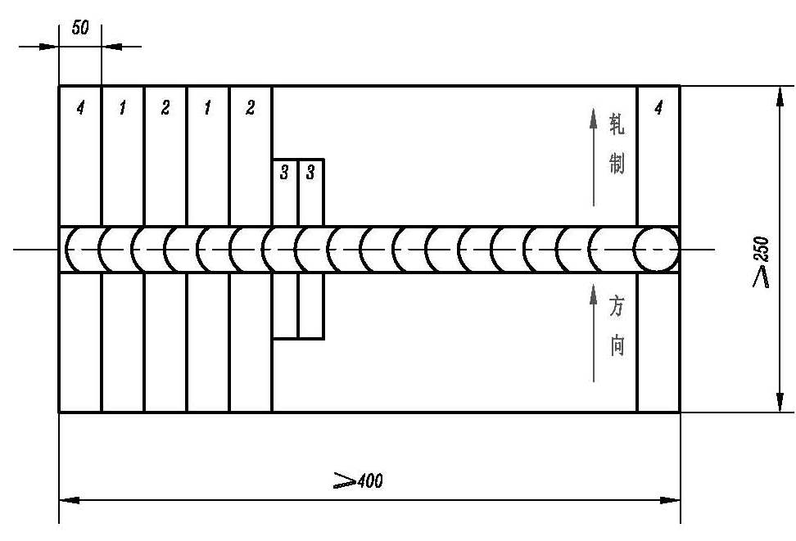
1-tensile specimen; 2-Bending specimen; 3-intergranular corrosion specimen; 4-discarded part
Figure 9 Sampling diagram of mechanical properties and corrosion test on welding test plate
      - The weld section shall be in good condition and free of defects such as crack, incomplete fusion, incomplete penetration, slag inclusion and air hole.
      - The mechanical property test results shall meet the following requirements：
a) The measured tensile strength RMA of the base metal of the bottle body shall not be less than the lower limit of the standard value of the base metal；
b) No matter where the fracture takes place, the measured tensile strength Rma shall not be less than the lower limit of the standard value of the base metal；
c) When the welding joint specimen is bent to 180 °, there shall be no cracks or other defects on its tensile surface in any direction, and the early cracks on the edge of the specimen shall not be counted.
      - For the steel cylinder with intergranular corrosion medium, intergranular corrosion performance test shall be carried out for the cylinder material and weld in contact with the medium. Corrosion test method and evaluation standard shall be in accordance with GB / T 4334-2008 "method e" or design drawing. The "H" mark shall be marked on the location specified in the steel seal mark area of the cylinder.
      - Hydraulic burst test
a) For cylinders with volume less than or equal to 150L and large volume cylinders with steel seal directly printed on the head, hydrostatic blasting test shall be carried out；
b) The volume residual deformation rate of the cylinder body under the test pressure shall not be more than 10%；
c）The burst pressure (p b ) shall be at least 2,25 times the test pressure. The observed yield
pressure (p y ) shall be equal to or greater than the value calculated by the following formula:：P_{y}≥P_{h}/F；
d) The main fracture shall not show any brittleness, i.e. The edges of the fracture shall not be radial but shall be at an angle to a diametral plane, and shall not occur on the head (except for the cylinder with only one circumferential joint and l ≤ 2 D)；For the cylinder with steel seal mark printed on the head, the starting point of the crack shall not be at the steel seal.
e) The blasting opening of the bottle body shall be plastic fracture, and the fracture shall have obvious shear lip, but no obvious defect.
      - Pressure cycling test
a) The pressure cycling test shall be carried out on three cylinders bearing the required stamp markings.
b) This test shall be carried out with a non-corrosive liquid, subjecting the cylinder to successive reversals at an upper cyclic pressure which is equal to the hydraulic test pressure. The value of the lower cyclic pressure shall not exceed 10 % of the upper cyclic pressure. The frequency of reversals of pressure shall not exceed 0,25 Hz (15 cycles/min). The temperature measured on the outside surface of the cylinder shall not exceed 50 °C during the test.
c) The cylinder shall be subjected to 12 000 cycles without leakage or failure.
    - Annex
      - The structural design and layout of accessories shall be convenient for operation and inspection of welds，The welding joint between the accessories and the bottle body shall avoid the longitudinal and circumferential welding joints of the bottle body，The structure and shape of the accessories and their connection with the bottle body should be prevented from causing liquid accumulation.
      - The structure of the base shall ensure the stability of the cylinder when it is upright and have holes for liquid drainage and ventilation。
      - Lifting holes shall be provided when the total mass of the cylinder containing the medium exceeds 100 kg。
      - The valve shall meet the requirements of the contained medium, and the screw thread of the bottle valve shall match the screw thread of the bottle mouth and conform to the provisions of GB 8335. The valve outlet of combustible gas cylinder shall be left-hand thread. The valve outlet of dissolved gas cylinder shall be of clamp type structure。
      - Cylinder shall be equipped with cap or shield。
      - The sealing material shall be compatible with the medium.
      - When the safety relief device is installed, its material shall be compatible with the medium in the bottle and shall not affect the quality of the filling medium.
      - No safety relief device shall be installed on the steel cylinder of highly toxic medium. The toxicity classification of medium shall be in accordance with the provisions of GB / T 16163.
    - Appearance
      - The surface oil stain and welding spatter shall be removed and kept dry。
      - Cleaning, pickling and passivation of internal and external surfaces shall be in accordance with the drawing.
  - Test methods
    - Material reinspection
The main material of cylinders shall be retested for chemical composition according to heat number and mechanical properties according to batch number, and sampling analysis and test shall be conducted according to the method specified in the material standard.
    - Mechanical property tests of welding procedure qualification test plate
      - The cutting position shall refer to Figure 9 when the samples are cut from welding procedure qualification test plate meet the requirements 6.2.2, and the part to be cut off at both ends shall not be less than 50mm; when the sample is cut from cylinder, the cutting position shall refer to Figure 7 and Figure 8. The sample shall be cut by machining and heat affect zones shall be removed when thermal cutting is used.
      - Number of welding samples for welding procedure qualification: 2 tensile samples, 4 transverse bend samples (2 face bend and 2 root bend).
      - The face and root surface of weld of the sample shall be machined to make it flush with the parent material, and the uneven sample can be leveled by cold compression method.
      - The tensile specimen shall be prepared according to Figure 10, and tensile test shall be conducted in accordance with GB/T 228.1.
unit:mm
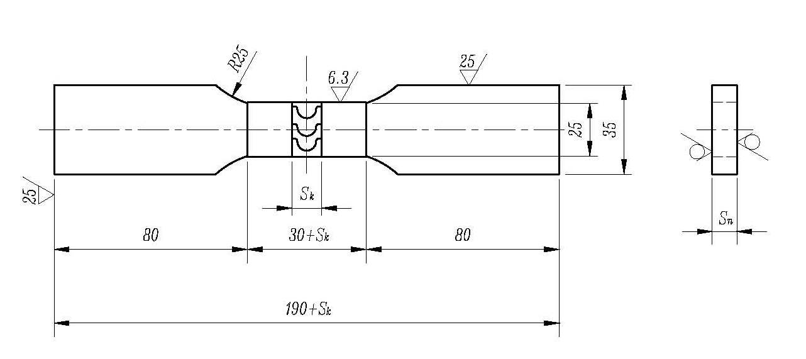
Figure 10 Dimensions of test sample

      - The bend test shall be carried out in accordance with GB/T 232, and the bend sample width is 38mm. The axis of the bending shall be located in the center of the weld, and two rollers shall be such that the specimen does not contact their sides (see Figure 11). The ratio n of the bending diameter D and the specimen thickness S_{h} shall meet the requirements of Table3, and the bending angle shall meet the requirements of 6.14.6c.
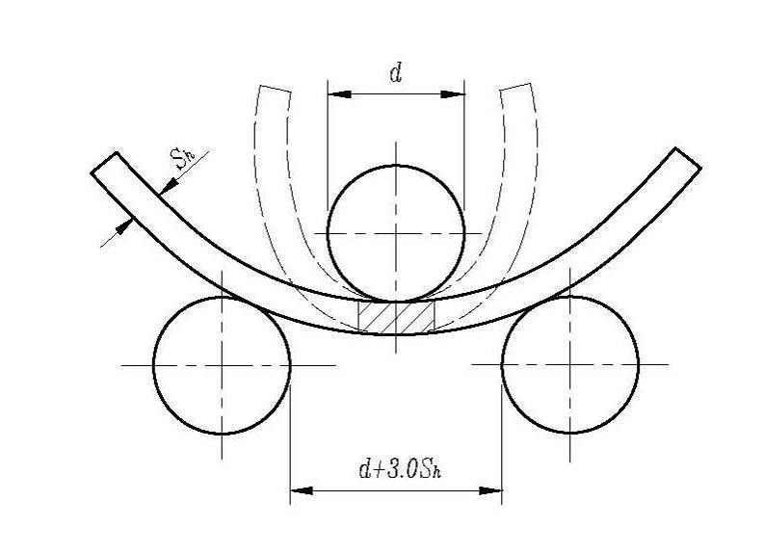
Figure 11 Illustration of bend test

Table3 Test requirement
Actual tensile strength（R_{ma} ） MPa | Value of n
R_{ma} ≤ 440 | 2
440＜ R_{ma}≤ 520 | 3
520＜ R_{ma＜}≤ 600 | 4
600＜ R_{ma}≤ 700 | 5
R_{ma}＞ 700 | 6

    - Radiographic examination of welds
The radiographic examination of longitudinal and circumferential welds of the cylinder shall be carried out in accordance with NB/T 47013.2 or GB/T 17925. The radiographic positions shall include the parts specified in 6.4.3, and other parts shall be determined by radiographic inspection or quality inspection personnel.
    - Mechanical property tests of parent material and welds
      - Samples taken from cylinders

7.4.1.1 One parent material tensile sample longitudinally taken from cylindrical body for two-part cylinders, and cut it from the convex part of the head if the length of cylindrical body is not enough. Weld samples taken from circumferential welding: 1 tensile sample, 1 transverse face bend sample and 1 root bend sample, and the cutting position is shown in Figure 9.

7.4.1.2 One sample longitudinally taken from the cylindrical body and one sample taken from convex part of any heads for three-part cylinders from the section 180°away from the longitudinal weld. The same amount of samples shall be cut from the circumferential welding if different welding process methods are adopted of circumferential welding and longitudinal welding (see Figure 8).
      - Weld samples taken from product welding test plate: 2 tensile samples, 1 transverse face bend sample and 1 root bend sample, and the dimensions of the test plate and the cutting position of the samples are shown in Figure 9.
      - The method of cutting samples taken from cylinders or product welding test plate shall meet the provisions of 6.14.
      - The processing of welds shall meet the provisions of 7.2.3.
      - The manufacturing and tests of the parent material tensile samples shall be carried out in accordance with GB/T 228.1.
      - The manufacturing and tests of tensile and bending samples of welds shall meet the provisions of 7.2.4 and 7.2.5.
    - Determination of weight and volume
      - Use the weighing method to measure the mass and volume of the cylinder. The unit of mass is kg and the unit of volume is L.
      - The weighing instrument with the maximum weighing of 1.5-3.0 times of the actual weighing shall be used, and its accuracy shall meet the requirements of the minimum weighing error, and its verification period shall not exceed three months.
      - Three significant figures shall be reserved for the measurement, the remaining figures shall be 1 for the mass and rounded off for the volume. Examples are as follows：
Measured net weight and volume 1.064 5 10.676 106.55
weight 1.07 10.7 107
volume 1.06 10.6 106
    - Wall thickness measurement
The thickness of the bottle body is measured by ultrasonic thickness gauge。
    - Pressure test
      - Hydrostatic test or pneumatic test shall be adopted for pressure test of cylinders.
      - The hydrostatic test of cylinders shall be carried out in accordance with GB/T 9251. The pressure shall be slowly increased to the test pressure at a rate of less than 0.5MPa per second, and maintained at least 30s.
      - For pneumatic test of cylinders, the pressure shall be increased to 10% of the test pressure at first, and all welds and connecting parts shall be inspected; then increase it to 50% of the test pressure if there is no leakage; then increase the pressure step by step according to 10% of the specified test pressure until it reaches to the test pressure, and maintained at least 10s. Reduce the pressure to nominal working pressure, and conduct the leakage test.
    - Leakage test
Leakage test of cylinders shall be carried out in accordance with GB/T 12137.
  - Hydraulic burst test
Hydraulic burst test shall be carried out in accordance with GB/T 15385.
  - Intergranular corrosion test
Intergranular corrosion test shall be carried out in accordance with GB/T 4334-2008 “Method E” or design drawing.
  - Pressure cycling test
Pressure cycling test shall be carried out in accordance with GB/T 9252.
  - Visual and accessories examination
Visual examination of the weld appearance marks and accessories of cylinders.
  - Verticality examination
Check the verticality with an angle ruler or testing tool.
  - Verification
    - Material test

Manufacturers shall verify the chemical composition of the finished product on the basis of the heat number of the used materials according to 7.1, and conduct the mechanical property verification test on the basis of the batch number.
    - Tests on every cylinder
      - The inspection of steel cylinders one by one shall be carried out according to the items specified in Table 4.
      - For cylinders designed with a welding joint coefficient of φ = 0.9, for cylinders with one longitudinal welding joint and two circumferential welding joints. The longitudinal and circumferential welded joints shall be subject to radiographic inspection of not less than 20%.If any defect beyond the standard is found, radiographic inspection shall be carried out by extending 20% of the length of the welding joint at both ends of the defect. If the length of one end is not enough, make up at the other end. If there are still defects beyond the standard, the welded joint of the gas cylinder shall be subject to 100% RT.
    - Batch test
      - Batch and sampling rules

8.3.1.1 If only one circumferential welding joint, and the steel cylinder designed with the welding joint coefficient φ = 0.9 is adopted. The first piece produced by each machine in each shift and the next 50 pieces produced in sequence (one piece shall be taken if less than 50 pieces) are selected for the radiographic inspection of the whole weld length.

8.3.1.2 For cylinders with a nominal volume less than or equal to 150L, no more than 200 cylinders shall be taken as a batch, and one mechanical property test cylinder shall be taken from each batch.

8.3.1.3 For cylinders with a nominal volume greater than 150L, no more than 50 cylinders shall be taken as a batch, and a product welding test plate shall be made for mechanical property test.
      - Batch inspection items
Batch inspection items shall be in accordance with table 4.
      - Reinspection rule

8.3.3.1 The unqualified items found in the batch inspection need to be retested.

8.3.3.2 If there is evidence that the test failed due to operation error or test equipment failure, the second test can be conducted on the same cylinder (or another cylinder in the same batch if necessary) or the welding test plate of the original product. If the second test is qualified, the first test can be ignored.

8.3.3.3 Steel cylinder for radiographic testing as per 8.3.1.1, When the radiographic inspection of the whole length of the weld is unqualified, two more cylinders shall be selected from 50 cylinders in the same production sequence for radiographic inspection of the whole length of the weld. If it is still unqualified, radiographic inspection shall be carried out for the whole length of the weld one by one.

8.3.3.4 If the mechanical property test of steel cylinder with nominal volume less than or equal to 150L is unqualified, two of the same batch shall be re inspected.

8.3.3.5 If more than one steel cylinder fails to pass the re inspection as per 8.3.3.4, the batch of steel cylinders is unqualified.

8.3.3.6 For cylinders with a nominal volume greater than 150L, if there is any unqualified item in the mechanical property test of the welding test plate of the product, and it is still unqualified after double retest, it is allowed to select one of the cylinders in this batch, and cut the sample according to the provisions of 7.4.1.2 for retest. If there are any unqualified items, these steel cylinders are unqualified.
  - Type test
    - For each new design, the manufacturer shall provide not less than the number of cylinders required for the test for type test, and the cylinders provided for type test shall be inspected one by one according to Table 4.
    - Requirements for type test
      - Tensile test

Randomly select one cylinder for tensile test of parent material and welds according to 7.4; for cylinders of nominal water capacity greater than 150L, a product welding test plate can be manufactured according to 6.14.4, and the tensile test of the welds can be carried out according to 7.4.2
      - Hydraulic burst test
      - For cylinders of nominal water capacity less than or equal to 150L, randomly select one cylinder for hydraulic burst test according to 7.9.
      - Corrosion test
An intergranular corrosion test of cylinder material shall be carried out according to 7.10 for cylinders which are intended to be used for corrosive application.
      - Pressure cycling test
The pressure cycling test shall be carried out on 3 randomly selected cylinders bearing the required stamp markings according to 7.11.
    - In the event of following situations, retesting of type test shall be carried out.
a) Change of cylinder material or design wall thickness;
b）Design change of cylinder welding (longitudinal welding of cylinder body、circumferential welding between head and cylinder body) and head;
c）Water capacity change of cylinder more than 30%.

Table 4 list of inspection and test items
Serial | Inspection items |  | Test by test | Batch test | Type test | Test method | Judgement basis
1 | Chemical composition and mechanical properties of main materialsª |  | - | - | - | 7.1 | 4.2
2 | body | Maximum and minimum diameter e | Δ | - | - | 6.6.2 | 6.6.2
3 | body | Butt stagger of longitudinal welded joint b | Δ | - | - | 6.6.3 | 6.6.3
4 | body | Edge height of longitudinal welded joint E | Δ | - | - | 6.6.4 | 6.6.4
5 | body | Straightness | Δ | - | - | 6.9.3 | 6.9.3
6 | seal | Tolerance of inner circle circumference πΔD_{i} | Δ | - | - | 6.7.2 | 6.7.2
7 | seal | surface relief c | Δ | - | - | 6.7.2 | 6.7.2
8 | seal | Maximum and minimum diameter difference e | Δ | - | - | 6.7.2 | 6.7.2
9 | seal | Surface to template gap α | Δ | - | - | 6.7.2 | 6.7.2
10 | seal | Internal height toleranceΔ H_{i} | Δ | - | - | 6.7.2 | 6.7.2
11 | seal | Longitudinal fold depth of straight edge | Δ | - | - | 6.7.4 | 6.7.4
12 | Butt stagger of circumferential welding joint b |  | Δ | - | - | 6.9.2 | 6.9.2
13 | Edge angle of circumferential welded joint E |  | Δ | - | - | 6.9.2 | 6.9.2
14 | Cylinder surface |  | Δ | - | - | 7.12 | 6.10
15 | Weld appearance |  | Δ | - | - | 7.12 | 6.3.8
16 | Wall thickness of bottle body |  | Δ | Δ | - | 7.6 | 6.7.3、5.2
17 | Radiography |  | Δ | Δ | - | 7.3 | 6.4.4
18 | mechanical property |  | - | Δ | Δ | 7.4 | 6.14.6
19 | Intergranular corrosion^{b} |  | - | - | Δ | 7.10 | 6.14.7
20 | volume |  | Δ | - | - | 7.5 | 6.12.1
21 | weight |  | Δ | - | - | 7.5 | 6.12.2
22 | Pressure test |  | Δ | - | - | 7.7 | 6.13.1
23 | Air tightness test |  | Δ | - | - | 7.8 | 6.13.2
24 | Hydraulic blasting test^{c} |  | - | - | Δ | 7.9 | 6.14.8
25 | Pressure cycling test^{d} |  | - | - | Δ | 7.11 | 6.14.9
26 | Annex test |  | Δ | - | - | 7.12 | 6.15
27 | Verticality inspection |  | Δ | - | - | 7.13 | 6.9.4
Remarks ：“Δ”Items to be inspected，“-” Non inspection items .
ª Retest chemical composition according to heat number and mechanical properties according to batch number ;
^{b} Intergranular corrosion test shall be carried out for steel cylinder containing intergranular corrosion medium;
^{c} For cylinders with volume less than or equal to 150L and large volume cylinders with steel seal directly printed on the head, hydrostatic blasting test shall be carried out;
^{d} Type test only for cylinders with steel seal directly pressed on the head.

  - Marking, packaging, transportation and storage
    - The steel seal mark of gas cylinder should be printed on the shield, base or seal welding nameplate；When the steel seal mark is printed on the head, the fatigue test and hydraulic blasting test shall be passed, and the crack starting point shall not be at the steel seal.
    - The content and layout of the steel seal mark shall conform to the provisions of relevant laws and regulations and cylinder design drawings. The design wall thickness of the bottle body in the mark shall be the thicker one of the design wall thickness of the cylinder or head. For cylinders containing intergranular corrosive media, the "H" mark shall be marked in the steel seal mark.
    - The type, color and mark of the cylinder shall conform to the provisions of Appendix A.
    - The packaging of ex factory steel cylinder shall be carried out according to the requirements of packaging in the agreement signed with the user. If the user has no requirements, it shall be carried out according to the technical regulations of the manufacturer. The cylinder shall be protected from collision, scratch and damage to accessories during transportation and loading and unloading.
    - The cylinder shall be stored in a place free of corrosive gas, ventilated, dry and exposed to sunlight, and avoid contact with carbon steel.
  - Factory documents
    - Each steel cylinder delivered from the factory shall be attached with a product certificate. The contents recorded in the product certificate shall be consistent with the production inspection records kept by the manufacturer. See Appendix B for the format and contents of the product certificate.
    - Each batch of steel cylinders delivered from the factory shall be attached with batch inspection quality certificate. When there is more than one user for this batch of steel cylinders, a copy of the batch inspection quality certificate can be provided to the user. See Appendix C for the format and content of the batch inspection quality certificate.
    - The manufacturer shall properly keep the inspection records of steel cylinders and the copies or originals of quality certificates for batch inspection for at least 7 years.

Appendix A
（Normative annex）
Color mark of stainless steel welded gas cylinder

A.1 Surface identification of stainless steel welded gas cylinder

A.1.1 For the steel cylinder with coating treatment, the surface color, character color and other marks of the cylinder shall comply with the provisions of GB / T 7144.

A.1.2 For the steel cylinder whose surface is polished, its body shall keep its stainless steel natural color and not be coated with color. But it is necessary to paste "media label" on its surface for identification.

A.2 Design requirements for medium label of stainless steel welded gas cylinder
A.2.1 The contents of media label shall at least include: media name, media symbol, nominal working pressure of gas cylinder, test pressure of gas cylinder, quality of gas cylinder, nominal volume of gas cylinder, maximum filling amount of media and other characteristic data.

The quality of gas cylinder can be replaced by theoretical quality, but the theoretical quality value shall not be greater than the actual quality.

A.2.2 The media label shall indicate the name and symbol of the media in striking font, and the media name or symbol shall be consistent with the media in the cylinder mark. The character height of media name and media symbol shall not be less than 40mm. The example of media label is shown in Figure a.1. Its content layout can be adjusted as required.
Note: the character height of medium name and symbol on label of small volume gas cylinder can be reduced appropriately.

A.2.3 The media label shall indicate the maximum filling amount of media (kg), which is consistent with the maximum filling amount in the cylinder mark.

A.2.4 The background color and character color of the media label shall comply with the provisions of the bottle color and character color of the corresponding media in GB / T 7144.

A.2.5 Media label can be made of color printing, plastic sealing, single-sided adhesive.

A.2.6 Paste of media label

The media label shall be pasted on the appropriate part of the bottle body. For vertical gas cylinder, the label shall be pasted vertically on the appropriate part of the upper part of the cylinder body, and the longitudinal welding joint weld shall not be covered. For horizontal gas cylinder, the label shall be horizontally arranged in the middle of the cylinder body.

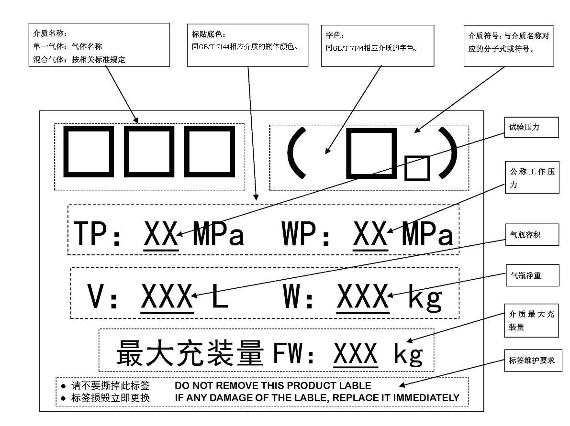
Figure a.1 schematic diagram of media label

Appendix B
（Informative appendix）
Product certificate
The specification of the product qualification certificate shall be unified, and the surface center size is recommended to be 150 mm × 100 mm.
Examples of product certificates are as follows：
（Name of manufacturer）

Stainless steel welded gas cylinder
Product certificate

Name of cylinder

Product number

Manufacturing date

Manufacturing license

This product is manufactured in accordance with the requirements of GB ××× - 201 × "stainless steel welded gas cylinder" and the design drawing.
Qualified after inspection.

Chief of inspection section (seal) Special seal for quality inspection

y m d

Main technical data
Nominal volume L | Actual volume L
Inner diameter mm | Total length mm
Filling Medium | Maximum filling capacity kg
Design wall thickness of cylinder mm | Design wall thickness of head mm
Bottle material brand | Material standard No
Specified value of material chemical composition / %
C | Si | Mn | P | S | Cr | Ni | Mo | Cu | N | others
Specified value of material strength：
R_{m} MPa | R_{p0.2} MPa
Cylinder weight (excluding detachable parts)： kg
Hydrostatic test pressure MPa Air tightness test pressure MPa
Coefficient of welded joint φ
Radiographic examination of welded joints
According to standard
Detection ratio
Qualification level
detection result
Welding repair times
1 time ； 2 times ； 3 times
Welding repair part deployment diagram
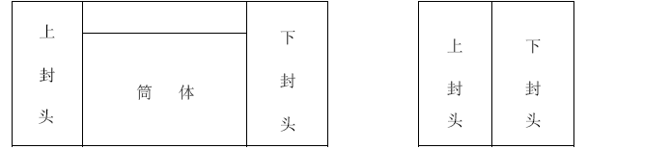
（Three parts） （Two parts）

Instructions for use：

Cylinder diagram：

Appendix C

（Informative appendix）
Quality certificate of batch inspection
The specifications of the batch inspection quality certificate shall be unified, and the recommended surface center size is 150 mm × 100 mm.
An example of quality certificate for batch inspection is as follows：
Name of manufacturer
Stainless steel welded gas cylinder
Quality certificate of batch inspection

Name of cylinder
Containing medium and chemical formula
Design approval drawing
batch number
Manufacturing date
Manufacturing license No
This batch of steel cylinders ，The number is from No. to No. , and it is in conformity with the inspection and test
The requirements of GB ××××-201×stainless steel welding gas cylinder and design drawing are qualified products。

Special seal for inspection of manufacturer

Chief of inspection

y m d

Address of manufacturer： Postal Code：
Telephone：

1 Main technical data
Nominal volume L Nominal working pressure MPa
Nominal diameter mm Hydrostatic test pressure MPa
Nominal wall thickness of bottle mm Air tightness test pressure MPa
2 Measurement of test bottle (when v > 150 l, the bottle with test plate)
Cylinder number | Actual volume /L | weight/kg | Minimum measured wall thickness /mm |  | Heat treatment heat number
Cylinder number | Actual volume /L | weight/kg | body | seal | Heat treatment heat number
Note: net weight does not include detachable parts.
3 Chemical composition of cylinder material / %
Numbering | Brand name | C | Si | Mn | P | S | Cr | Ni | Mo | Cu | N | other
Specified value of standard
4 welding material
Welding wire grade | welding wire /mm | Flux grade
5 Radiographic examination of welded joints
Weld length mm Inspection ratio %
NB/T 47013.2 Grade qualification
GB/T 17925 Grade qualification
Test cylinder (when v > 150L, it refers to the bottle with test plate)
Repair 1 times place，Repair 2 times places，Repair 3 times places
6 Mechanical property test
Test plate number | tensile strength  R_{m}/MPa | Elongation rate  A/% | Bending test
Test plate number | tensile strength  R_{m}/MPa | Elongation rate  A/% | Transverse bending | Transverse back bending
samples | 2 | 2 | 1 | 1
Note: there is no elongation index for welding sample.
7 Intergranular corrosion test
Test according to "method e of GB / T 4334-2008"，results 。
Special seal for quality inspector

Reference
[1] GB 5100 Steel welded gas cylinder
[2] TSG R0006 Supervision regulation of gas cylinder safety technology

